Professional ReactJS



Completed source code for all labs (for checking your work) can be found at:

https://github.com/chrisminnick/professional-reactjs



Version 19.2.2, March 2025

by Chris Minnick

Copyright 2025, WatzThis?

www.watzthis.com

# Table of Contents

Table of Contents 2

Disclaimers and Copyright Statement 4

Disclaimer 4

Third-Party Information 4

Copyright 4

Help us improve our courseware 4

Credits 5

About the Author 5

Course Requirements 6

Introduction and Git Repo Info 6

Yarn or npm? 6

Lab 01: Get Started with Vite / React 7

Lab 02: Your First Component 9

Lab 03: Create More Components and Writing Tests 10

Part 1: Making new components 10

Part 2: Writing tests 10

Lab 04: Static Version 12

Lab 05: DOM Manipulation and Modern JavaScript 14

PART I. Working with an API 14

PART II JSON 16

PART III. DOM Manipulation/Writing Functions 24

PART IV - Events 33

Lab 06: Styling React 35

Lab 07: Props and Containers 38

Lab 08: Adding State 41

Lab 09: Interactions, Events, and Callbacks 44

React's Synthetic Events 44

Unidirectional Data Binding 44

State in a Class Component 44

Lab 10: Component Lifecycle and AJAX 50

Lab 11: Converting App to a Function Component 53

Lab 12: Creating and using a color theme context 54

Lab 13: Custom Hooks 56

Lab 14: Converting to TypeScript 57

Lab 15: Testing with React Testing Library 60

Lab 16: Implementing Redux 62

Step 1: Create a store 62

Step 2: Write the reducers 62

Step 3: Write the Actions and Action Creators 63

Step 4: Modify App.tsx to use the Redux store. 65

Lab 17: Redux Thunk 67

Lab 18: Persisting data in localStorage using Redux 69

Lab 19: React Router 71

Lab 20: Microfrontends with Single SPA 72

Bonus Lab: Authentication with JWT 74

Bonus Lab: React Asteroids 75

# Disclaimers and Copyright Statement

## Disclaimer

WatzThis? takes care to ensure the accuracy and quality of this courseware and related courseware files. We cannot guarantee the accuracy of these materials. The courseware and related files are provided without any warranty whatsoever, including but not limited to implied warranties of merchantability or fitness for a particular purpose. Use of screenshots, product names and icons in the courseware are for editorial purposes only. No such use should be construed to imply sponsorship or endorsement of the courseware, nor any affiliation of such entity with WatzThis?.

## 

## Third-Party Information

This courseware contains links to third-party web sites that are not under our control and we are not responsible for the content of any linked sites. If you access a third-party web site mentioned in this courseware, then you do so at your own risk. We provide these links only as a convenience, and the inclusion of the link does not imply that we endorse or accept responsibility for the content on those third-party web sites. Information in this courseware may change without notice and does not represent a commitment on the part of the authors and publishers.

## 

## Copyright

All rights reserved. No part of this publication may be reproduced, distributed, or transmitted in any form or by any means, including photocopying, recording, or other electronic or mechanical methods, without the prior expressed permission of the owners, except in the case of brief quotations embodied in critical reviews and certain other noncommercial uses permitted by copyright law. For permission requests, write to the owners, at info@watzthis.com.

## 

## Help us improve our courseware

Please send your comments and suggestions via email to info@watzthis.com

# Credits

## About the Author

Chris Minnick is a prolific published author, trainer, web developer and founder of WatzThis, Inc. Minnick has overseen the development of hundreds of web and mobile projects for customers from small businesses to some of the world’s largest companies, including Microsoft, United Business Media, Penton Publishing, and Stanford University.

Since 2001, Minnick has trained thousands of Web and mobile developers. In addition to his in-person courses, Chris has written and produced online courses for Ed2Go.com, Skillshare, O'Reilly Media, and Pluralsight.

Minnick has authored and co-authored books and articles on a wide range of Internet-related topics including JavaScript, ReactJS, HTML, CSS, mobile apps, e-commerce, Web design, SEO, and security. His published books include JavaScript All-In-One For Dummies, Coding All-In-One For Dummies, ReactJS Foundations, JavaScript for Kids, Writing Computer Code, Coding with JavaScript For Dummies, Beginning HTML5 and CSS3 For Dummies, Webkit For Dummies, CIW eCommerce Certification Bible, and XHTML.

# Course Requirements

To complete the labs in this course, you will need:

* A computer with MacOS, Windows, or Linux.
* Access to the Internet.
* A modern web browser.
* Ability to install software globally (or certain packages pre-installed as specified below).

# Introduction and Git Repo Info

Most of the labs in this course build on the labs that came before. So, if you don't complete a lab or can't get a certain lab to work, it's possible that you can get stuck and won't be able to move forward until the error is corrected.

To help you check your work and to make it possible to come into the class at any point, the git repository for this course contains finished versions of every lab.

The url for the course repository is:

https://github.com/chrisminnick/professional-reactjs

You can find the finished code for each lab inside the **solutions** directory.

# Yarn or npm?

Yarn and npm are both package managers for Node. Yarn was developed by Facebook, and npm is included with Node. You can use whichever one you prefer for all the labs in this course, but the instructions in this course use npm to keep the number of required pre-requisite installations to a minimum.

If you want to try Yarn, or if you prefer it to npm, you must have it installed globally on your computer. You can find instructions for installing Yarn here: <https://yarnpkg.com/getting-started/install>

# Lab 01: Get Started with Vite / React

1. Open a new Terminal in VSCode.
2. Use Vite to make a new React project. This will be the project we'll be working on for most of the labs in this course.

npm create vite@latest react-bookstore -- --template react

If this produces an error, you most likely need to upgrade the version of node and npm on your computer (see the setup instructions).

1. Go into the new directory.

cd react-bookstore

1. Install the dependencies.

npm install

1. Test that everything was installed and works.

npm run dev

After a moment, you'll see a url in the terminal. Ctrl-Click the URL to open it in your default browser, or open a browser and go to the URL manually.

If the app was successfully created, you should see the following page:

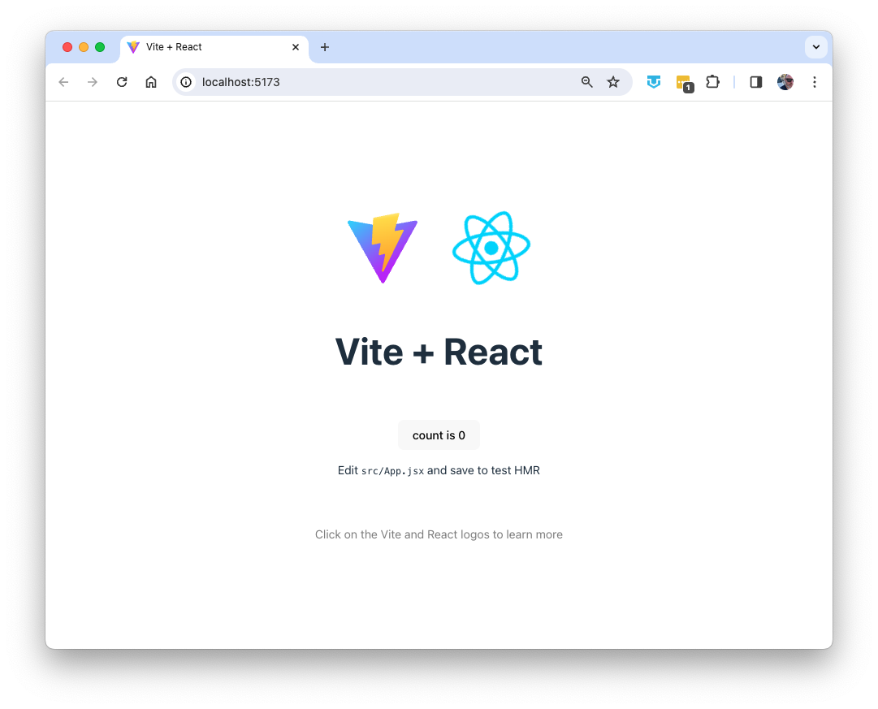

1. Find **App.jsx** inside the **src** directory and open it for editing.
2. Inside the return statement, delete the <div> containing the Vite and React logos.
3. Delete the logo import statements from the beginning of the file.
4. Change the text inside the <h1> element to Welcome to React Bookstore.
5. Create a new <p> element below the <h1> you added and change its content to a welcome message, such as the following:

We have several books. Feel free to browse for as long as you like. Click on a cover image to see details, or click the Add to Cart button to add a book to your shopping cart.

1. Open App.css and delete everything except for the first CSS rule:

#root {

max-width: 1280px;

margin: 0 auto;

padding: 2rem;

text-align: center;

}

1. Open index.css and delete the following rule:

body {

margin: 0;

display: flex;

place-items: center;

min-width: 320px;

min-height: 100vh;

}

1. Return to your web browser and notice that the text has been automatically refreshed (if your app is still running).

If it's doesn't refresh, click the browser refresh button, or return to your Terminal emulator and restart the development server (using npm run dev).

1. Click the button to see the counter increase. Exciting!
2. Delete the text below the counter.

If you get an error, make sure that all your opening tags have matching tags.

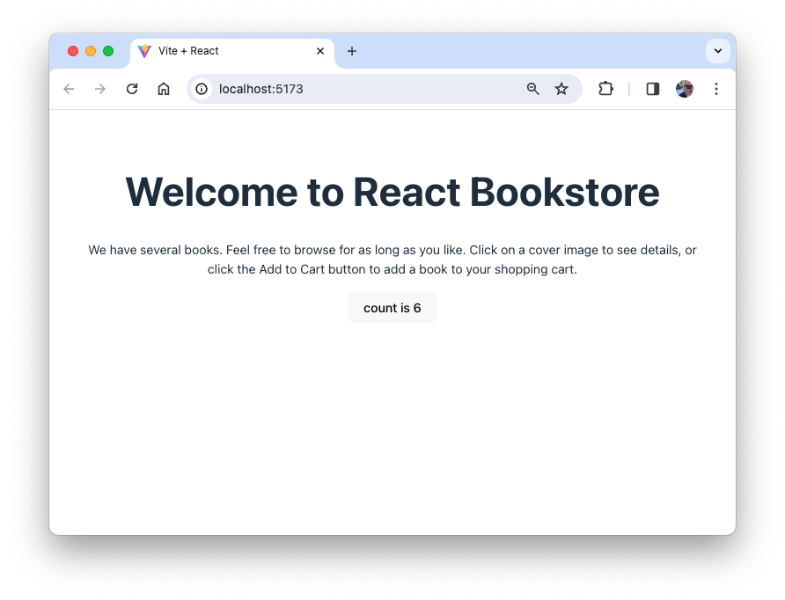

# Lab 02: Your First Component

React components let you divide your user interface into independent and reusable pieces. The simplest components simply output some piece of HTML, given some input. All that's required is a simple JavaScript function.

In this lab, you'll create a functional component to hold the contents of the page footer.

1. Create a new file named **Footer.jsx** in the **src** directory
2. Type the code below into **Footer.jsx**

function Footer() {

const footerStyle = {

backgroundColor: 'black',

color: 'white',

padding: '10px',

position: 'fixed',

left: '0',

bottom: '0',

margin: '0',

width: '100%',

};

return <p style={footerStyle}>This is the footer.</p>;

}

export default Footer;

1. Add the following to the beginning of **App.jsx**

import Footer from './Footer.jsx';

1. Add the following inside **App.jsx** (before </>).

<Footer />

1. Start the app (if it's not already running) and view it in your browser.

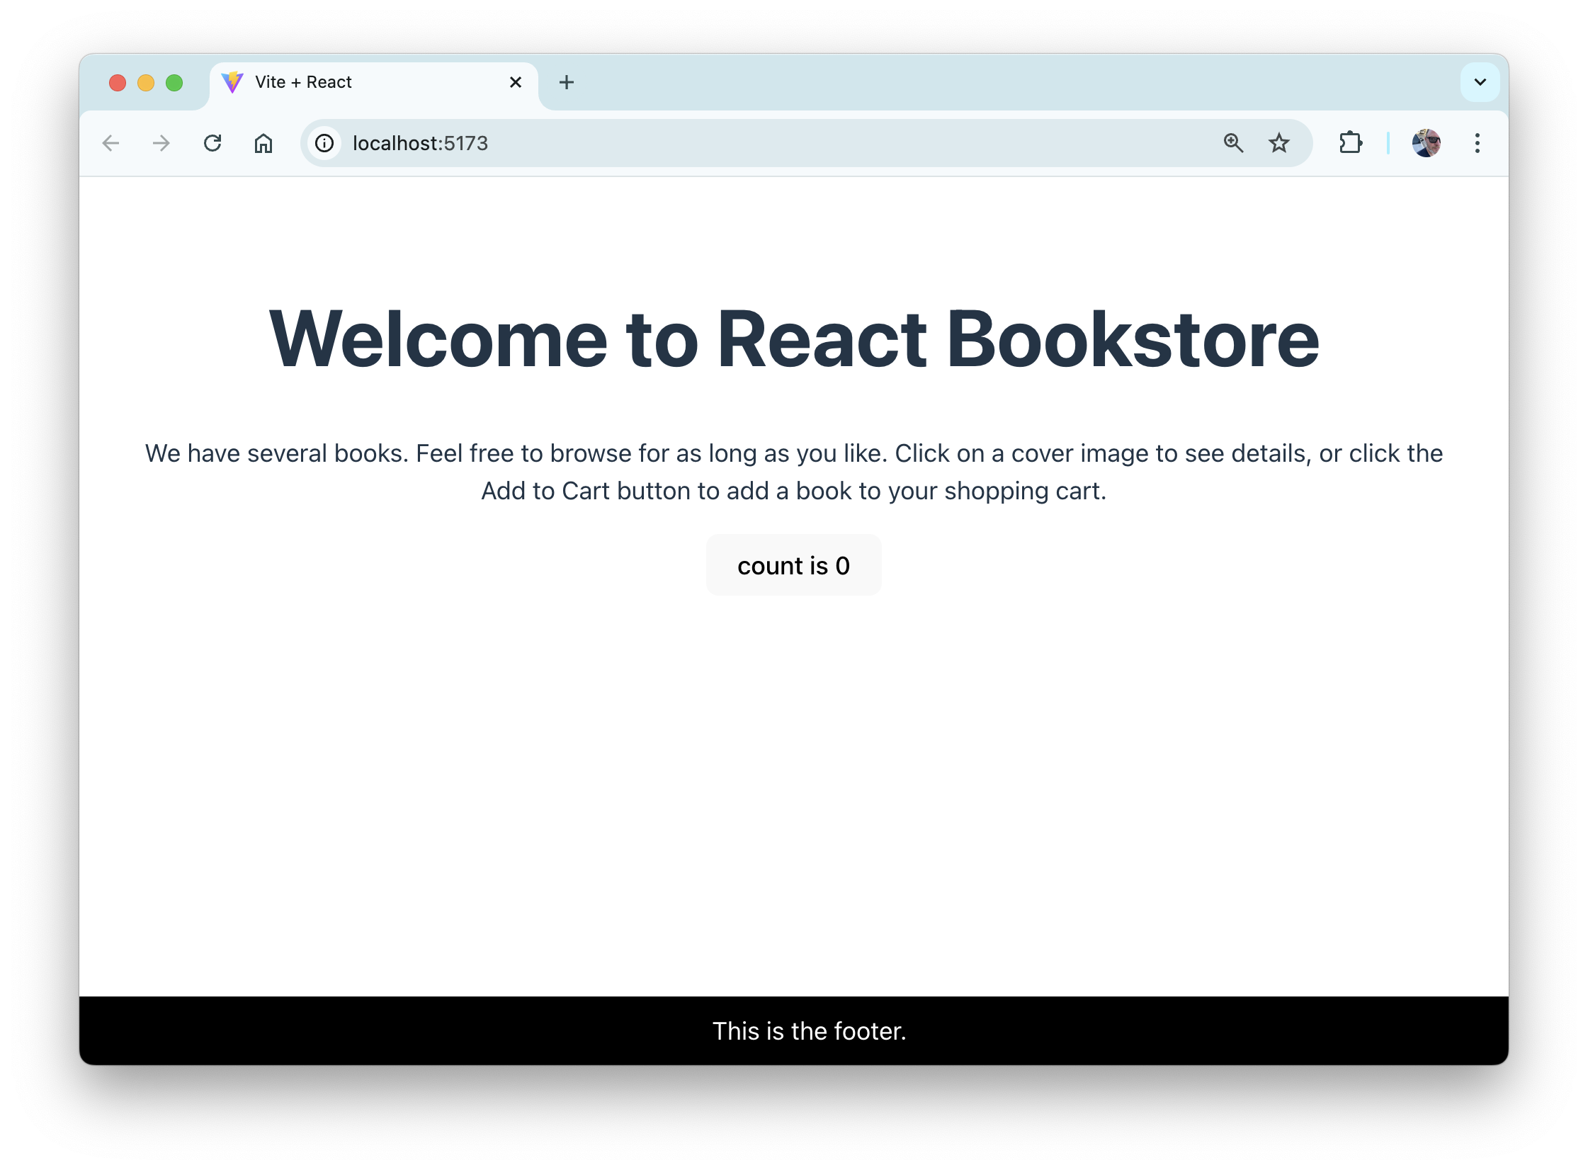

# Lab 03: Create More Components and Writing Tests

In this lab, you'll make your React application more modular by turning the main parts of the view into components, then you'll create simple tests for your new components.

## Part 1: Making new components

1. Using what you learned from creating **Footer.jsx**, make **Header.jsx** and **ClickCounter.jsx** to replace code in **App.jsx**.

At the end of this lab, your page should look the same as it does at the beginning when opened in a browser.

Your finished return statement in **App.jsx** should match this:

return (

  <div className="App">

    <Header />

    <ClickCounter />

    <Footer />

  </div>

);

Note: For the ClickCounter component to continue working, you'll need to move the useState import and the initialization of the count and setCount variables to ClickCounter.jsx.

## Part 2: Writing tests

To get started with testing, you'll need to install several dependencies, add a testing configuration to the Vite config file, and create a new test script in package.json. Follow these steps:

1. Install vitest and several other dependencies by running the following npm install commands in the terminal:

npm install --save-dev vitest

npm install --save-dev jsdom

npm install --save-dev @testing-library/jest-dom

npm install --save-dev @testing-library/react

npm install --save-dev @vitest/coverage-v8

1. Add the testing config to vite.config.js:

import { defineConfig } from 'vite';

import react from '@vitejs/plugin-react';

export default defineConfig({

plugins: [react()],

**test: { globals: true, environment: 'jsdom', },**

});

1. Add a test script to package.json:

"scripts": {

"dev": "vite",

**"test": "vitest --environment jsdom",**

1. Create a new file named App.test.jsx inside src.
2. Enter the following code into App.test.jsx:

import { describe, expect, it } from 'vitest';

import { render, screen } from '@testing-library/react';

import '@testing-library/jest-dom/vitest';

import App from './App.jsx';

describe('App Component', () => {

it('Renders', () => {

render(

<App />

);

let element = screen.getByText(/Bookstore/i);

expect(element).toBeInTheDocument();

});

});

1. Run your test script and confirm that your test passes:

npm run test

1. Make copies of **App.test.jsx** for testing **Footer.jsx**, **Header.jsx**, and **ClickCounter.jsx**
2. Modify the contents of the new files to test that the new components render.
3. Run your tests by entering the following in the command line

npm run test

1. Make sure that all the tests pass.

# Lab 04: Static Version

The first step in creating a React UI is to create a static version. In this lab, you'll start with a mockup of the react-bookstore application, and you'll create components to make a mockup of the catalog.

1. Open **professional-reactjs/starter/lab04/**.

You'll see three folders: **data**, **images**, and **mockup**.

1. Open **data/products.json** in your code editor.

This is a file in JavaScript Object Notation (JSON) containing 100 great books. We'll be building a store using this data.

1. Open **starter/lab04/mockup** and look at the **mockup.png** image.

This image shows what the final store and shopping cart should look like.

1. Figure out how you might divide the user interface shown in **mockup.png** into a hierarchy of components. Make a quick drawing on paper, or in MS Paint, or however you like. Check out **mockup-components.png** if you want to see one way it can be done.

**Hint 1:** If two components need to access the same piece of data, they should have a common parent that holds this data.

**Hint 2:** Look for repeating elements that can be made into components.

1. Move the **data** directory from the **/starter/lab04** directory into the **src** directory inside your **react-bookstore** project.
2. Move the **images** directory into the **public** directory.
3. Open the **App.jsx** component in your project and modify it to the following.

**NOTE:** Some of the components referenced in this code don't exist yet. You'll be creating them in the next step.

import Header from './Header.jsx';

import ProductList from './ProductList.jsx';  
import Cart from './Cart.jsx';

import Footer from './Footer.jsx';

import './App.css';  
  
function App() {  
 return (  
 <>

<Header />  
 <ProductList />  
 <Cart />

<Footer />  
 </>  
 );  
}  
  
export default App;

1. Create basic components for ProductList and Cart and their sub-components. Don't worry about styling them, but try to make each one contain the basic information (without images at this point) as in the mockup.
2. Create basic tests for each of the new components, using the same structure you used in the previous lab.
3. Run npm run dev to verify that your code builds. Your UI should now look something like this:

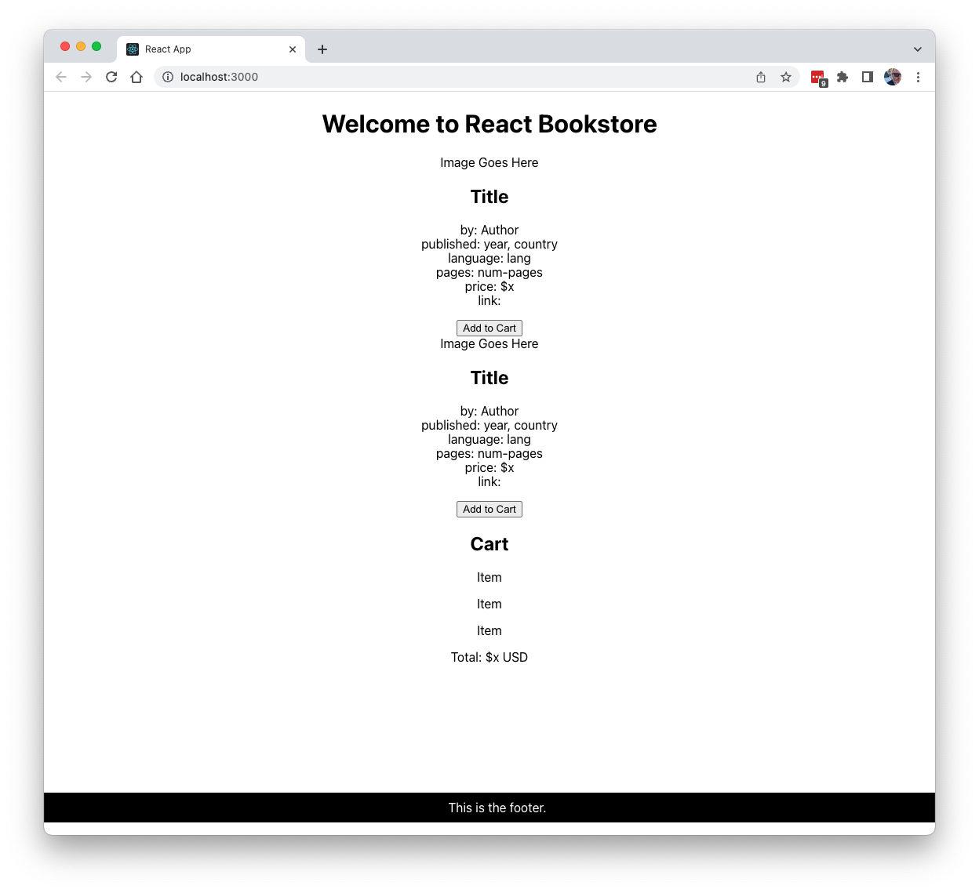

# Lab 05: DOM Manipulation and Modern JavaScript

## PART I. Working with an API

In this first part, you'll write a JavaScript application to make a call to NASA’s API to get data on the near-Earth asteroids based on their closest approach date to Earth. All the data is from the NASA JPL Asteroid team (<http://neo.jpl.nasa.gov/>). We are looking for data regarding the asteroids’ distance from the Earth, speed, size, and whether each asteroid is potentially hazardous.

1. In your code editor, create a new folder (outside of your other project folder) named asteroids.
2. Create a new file in the asteroids folder and name it asteroids.js.
3. Open asteroids.js and create a variable called today and set it to a string containing the current date.

const today = new Date().toISOString().slice(0,10);

We will need an *API key* to access NASA’s API. Without the key we would be limited as to how many calls we could make to the API per hour. With our key, we are allowed to call the API thousands of times per hour.

1. Navigate to https://api.nasa.gov/index.html#apply-for-an-api-key.
2. Enter your information and check your email for the API key. Congratulations, you have a developer’s API key from NASA!
3. Create a variable called key and set it equal to the API key from NASA.

const key = "your-very-own-and-very-long-key";

Next, if we are calling an API, how do we call it? We call the URL that NASA provides and add parameters to specify the data we want. Here is an example:

https://api.nasa.gov/neo/rest/v1/feed?start_date=START_DATE&api_key=API_KEY

Notice the parameters start_date and api_key. In the example, each parameter is set equal to a variable, either START_DATE or API_KEY. Here is where we will use our variables by using a template literal string.

1. Create the variable called url.

const url

1. Set the variable url equal to the string below.

Notice that the string begins and ends with a backtick and contains two variables.

const url = `https://api.nasa.gov/neo/rest/v1/feed?start_date=${today}&api_key=${key}`;

We are now ready to build the Asteroid class and a static method that that calls the API and that will make asteroid objects.

1. Create a new class named Asteroid, and give it a constructor.

class Asteroid {

constructor() {}

}

1. Each asteroid will have four properties: hazardous, distance, speed, and size. Add these as parameters to the constructor and initialize their corresponding properties:

constructor(isHazardous, distance, speed, size) {

this.isHazardous = isHazardous;

this.distance = distance;

this.speed = speed;

this.size = size;

}

1. Create a new static method named getAsteroids() in the Asteroid class. A static method is one that belongs to the class, rather than to instances of the class. Since we'll be running asynchronous code in this method, make it also be an async function:

static async getAsteroids() {

}

We’ll use the fetch() method inside getAsteroids() to get the data from the NASA API.

The fetch method provides a way for JavaScript to make HTTP requests asynchronously.

1. Call fetch() asynchronously, passing it the url, and assign the result to a constant named response.

const response = await fetch(url);

The response of a fetch request is a Stream object. Eventually, we want our fetch method to return JSON when it is successfully finished, as the promise of this finished stream.

Async functions wrap function calls made with the await keyword with a promise. What is a promise? A promise is a first-class representation of a value that may be made asynchronously and is available in the future. A promise represents the eventual result of an asynchronous operation. We don’t know if the call will be successful or not until the call is made, but we still must write our code moving forward as though it could be successful. If it is successful, we can do any number of things and continue with our coding. If it is not successful, we can return an error message.

1. To catch potential errors with the fetch(), wrap the async statement with a try/catch block:

static async getAsteroids() {

try {

const response = await fetch(url);

} catch (error) {

console.log(error);

}

It's also possible that the fetch() will be successful, but the response will be something other than what we want. For example, if you exceed your limit for API calls. To address that, we can check the value of response.ok.

1. Add a check for whether response.ok is true (inside the try block, after the fetch) and throw an error if it's not.

if (!response.ok) {

throw new Error('Network response was not ok');

}

1. Call the json() method on response to parse the stream as JSON and return a JavaScript object.

const data = await response.json();

1. Add console.log(data) so you can examine the data.

console.log(data);

Type about:blank into your browser's address bar to open a blank window. Copy your code and paste it into your browser's JavaScript console to run it. Type Asteroid.getAsteroids() in the console to call the static getAsteroids() method. After a moment, data should return from NASA and you'll see all the data for the asteroids based on the approach date that we chose.

To test your try/catch block, try refreshing your browser window, then paste the code into the console again and run getAsteroids(), but change the url to make it invalid (such as by changing nasa.gov to nasa.com).

## PART II JSON

Now we’d like to use the data we got from the NASA API. JSON is a data-interchange format that stands for “JavaScript Object Notation.” It is built on two structures:

* 1. Name/Value Pairs: JSON acts similarly to JavaScript objects. We know that an object is a collection of properties, and a property is made up of a name/value pairs, i.e const object = { 'name' : 'value' }
     1. We can access a value by name in two different ways., dot notation and bracket notation.

object.name => 'value'

object['name'] => 'value'

* 1. Arrays: In JSON, we also find ordered list of values, which we know are arrays, i.e., [ 'Bob', 'Jim', 'Lara'], which could be nested inside an object, i.e., const object = { 'names' : [ 'Bob', 'Jim', 'Lara'] }.
     1. To access an array inside JSON we need to first know what name is associated with the array, then access it by order (remember, arrays start at index 0).

object.names[0] => 'Bob'

object.names[2] => 'Lara'

Take a look in the console and browse the data printed to the console. Now that we have our data, how do we make sense of it? Remember, JSON is built on two structures, name/value pairs and arrays.

Let’s start to access the JSON to get the data we want. We want near Earth objects and we want them by a certain date. First, find the name near_earth_objects and expand it. You'll see a name, yyyy-mm-dd, similar to the format of the date string we created. If you expand one of those dates you'll see that it contains an array. This array is our list of asteroids!

Let’s access this collection of asteroids.

1. Inside the getAsteroids() function, comment out console.log(data) and create a variable called asteroids and set it equal to data.

//console.log(data);

const asteroids = data

1. Use dot notation to access near_earth_objects from data.

const asteroids = data.near_earth_objects

1. Use bracket notation, [today], after json.near_earth_objects.

We do this because we cannot access the collection by using dot notation with the yyyy-mm-dd format. We do know that our today variable is equal to the value or property of the object we wish to access. Therefore, we used the variable today in bracket notation.

const asteroids = data.near_earth_objects[today];

1. Print the collection of asteroids to the console by writing console.log(asteroids);

Reload your browser, paste your code into the console, then run the getAsteroids() method and search for names or properties that relate to distance, speed, size, and hazard info.

We see we have an ordered list of objects representing each asteroid. We can iterate or loop through this list and access the properties of distance, speed, size and whether or not it is hazardous for each object.

How do we loop through an array? There are a few ways to do this. We will use the .map() function. The map() function takes a callback function as an argument, performs that function on each element of the array, and creates a new array with the results of that callback. We need to write a function that, as we loop through each element of asteroids, accesses those values we want (distance, speed, size, hazard).

1. Chain .map() to our variable asteroids.

At this point, we can also remove our console.log statements.

const asteroids = data.near_earth_objects[today];

asteroids.map();

1. Pass the argument function(element) {} to the map() function.

We pass element to our callback function as an argument. This represents each element in our collection of asteroid objects. As we loop through the collection, we can execute code on each element.

const asteroids = json.near_earth_objects[today];

asteroids.map(function(element) {

});

1. In the block of code for the callback function of the map method, print element to the console. This will allow us to see each element in our collection. What names and values do you notice?

const asteroids = json.near_earth_objects[today];

asteroids.map(function(element) {

console.log(element);

});

If you run getAsteroids() in your console now, you'll see that each element that's logged by the map() function is an object and we can look for the properties of each asteroid. If you look closely, you'll see that these names correspond to the data we want (distance, speed, size, hazard info). We will start by looking into the name or property close_approach_data.

1. Create a variable called approach and set it equal to the element.

const asteroids = json.near_earth_objects[today];

asteroids.map(function(element) {

console.log(element);

let approach = element

});

1. Print approach to the console and comment out console.log(element).

We can now inspect our approach element to see what property we need to chain next.

const asteroids = json.near_earth_objects[today];

asteroids.map(function(element) {

//console.log(element);

let approach = element;

console.log(approach);

});

1. Use dot notation to chain close_approach_data onto our element.

const asteroids = json.near_earth_objects[today];

asteroids.map(function(element) {

//console.log(element);

let approach = element.close_approach_data;

console.log(approach);

});

When you print the variable approach to the console, you get an array with one element. Access that element, which is at the 0-index.

1. Use bracket notation, and write [0] after close_approach_data to access the array with one element.

const asteroids = json.near_earth_objects[today];

asteroids.map(function(element){

//console.log(element);

let approach = element.close_approach_data[0];

console.log(approach);

});

Further into this element, you'll see another object with an interesting property: miss_distance. We can now focus on distance, as we get closer to specific data.

1. Create a variable called distance and set it equal to approach. In the console.log command, replace approach with distance.

const asteroids = json.near_earth_objects[today];

asteroids.map(function(element){

//console.log(element);

let approach = element.close_approach_data[0];

let distance = approach;

console.log(distance);

});

1. Using dot notation to chain miss_distance onto approach.

const asteroids = json.near_earth_objects[today];

asteroids.map(function(element){

//console.log(element);

let approach = element.close_approach_data[0]

let distance = approach.miss_distance;

console.log(distance);

});

Printing distance to the console at this point reveals an object with properties that describe units of length. The values that are decimals in string format. For example:

[object Object] {

astronomical: "0.3577465984",  
   kilometers: "53518132",  
  lunar: "139.1634216309",

miles: "33254624"  
}

1. Chain the property .kilometers to the property miss_distance.

const asteroids = json.near_earth_objects[today];

asteroids.map(function(element){

//console.log(element);

let approach = element.close_approach_data[0];

let distance = approach.miss_distance.kilometers;

console.log(distance);

});

When you print distance to the console, you'll see it's a string that represents the distance of each asteroid from Earth in kilometers.

Let’s move on to accessing the speed of the asteroid. Print approach to the console. One name/property of this object is relative_velocity.

1. Create a variable called speed and set it equal to approach.

const asteroids = json.near_earth_objects[today];

asteroids.map(function(element){

//console.log(element);

let approach = element.close_approach_data[0]

let distance = approach.miss_distance.kilometers;

let speed = approach;

});

1. Chain .relative_velocity to approach in the speed variable.

Print speed to the console.

const asteroids = json.near_earth_objects[today];

asteroids.map(function(element){

//console.log(element);

let approach = element.close_approach_data[0]

let distance = approach.miss_distance.kilometers;

let speed = approach.relative_velocity;

console.log(speed);

});

If you view speed by printing it to the console, you'll see another object with more name/value pairs that measure the speed in different units. Let’s look at the name kilometers_per_hour.

1. Chain .kilometers_per_hour onto relative_velocity.

const asteroids = json.near_earth_objects[today];

asteroids.map(function(element){

//console.log(element);

let distance = approach.miss_distance.kilometers;

let speed = approach.relative_velocity.kilometers_per_hour;

console.log(speed);

});

When you print speed to the console, you'll get back a float, or a number that has a decimal point. This is the speed of each asteroid. You now have two points of data: distance and speed. Size is next.

Look back at the element, the original argument in our .map() function. If you print element to the console and look beyond and below the property close_approach_data, you'll eventually see the name estimated_diameter. Use that property of our element to access the size of each asteroid.

1. Create a variable called size. Set size equal to element and chain estimated_diameter to it.

const asteroids = json.near_earth_objects[today];

asteroids.map(function(element){

//console.log(element);

let distance = approach.miss_distance.kilometers;

let speed = approach.relative_velocity.kilometers_per_hour;

let size = element.estimated_diameter;

});

If you print size to the console, you'll get an object with properties of length. Look at the 'meters' property.

1. Chain .meters onto estimated_diameter.

const asteroids = json.near_earth_objects[today];

asteroids.map(function(element){

//console.log(element);

let distance = approach.miss_distance.kilometers;

let speed = approach.relative_velocity.kilometers_per_hour;

let size = element.estimated_diameter.meters;

});

When you print size to the console, you'll see an object that has two names relating to the estimated maximum and minimum size of the object. Since you never want to underestimate asteroids, go with the property estimated_diameter_max.

1. Chain .estimated_diameter_max after meters.

We now have the size data for each asteroid measured in meters.

const asteroids = json.near_earth_objects[today];

asteroids.map(function(element){

//console.log(element);

let distance = approach.miss_distance.kilometers;

let speed = approach.relative_velocity.kilometers_per_hour;

let size = element.estimated_diameter.meters.estimated_diameter_max;

});

Now you just need one more piece of data: Is the asteroid a hazard? Print element to the console and look beyond estimated_diameter. You'll see a property named is_potentially_hazardous_asteroid. This is it! The value of this property is a Boolean, simply true or false. It is a potentially hazardous asteroid or it is not. Good info to know, right?

1. Create a variable called hazard and set this equal to element.

const asteroids = json.near_earth_objects[today];

asteroids.map(function(element){

//console.log(element);

let distance = approach.miss_distance.kilometers;

let speed = approach.relative_velocity.kilometers_per_hour;

let size = element.estimated_diameter.meters.estimated_diameter_max;

let hazard = element;

});

1. Chain .is_potentially_hazardous_asteroid to element.

const asteroids = json.near_earth_objects[today];

asteroids.map(function(element){

//console.log(element);

let approach = element.close_approach_data[0]

let distance = approach.miss_distance.kilometers;

let speed = approach.relative_velocity.kilometers_per_hour;

let size = element.estimated_diameter.meters.estimated_diameter_max;

let hazard = element.is_potentially_hazardous_asteroid;

});

1. After the hazard variable, insert a console.log statement to log each piece of data about each asteroid to the console.

const asteroids = json.near_earth_objects[today];

asteroids.map(function(element){

let approach = element.close_approach_data[0];

let distance = approach.miss_distance.kilometers;

let speed = approach.relative_velocity.kilometers_per_hour;

let size = element.estimated_diameter.meters.estimated_diameter_max;

let hazard = element.is_potentially_hazardous_asteroid;

console.log(`

Hazard: ${hazardous}

Distance: ${distance} km

Speed: ${speed} km/h

Size: ${size} m

`);

});

1. Add a call to Asteroid.getAsteroids() to your asteroids.js file, after the class definition.

Here's what your getAsteroids() method should look like so far:

static async getAsteroids() {

try {

const response = await fetch(url);

if (!response.ok) {

throw new Error('Network response was not ok');

}

const data = await response.json();

console.log(data);

const asteroids = data.near_earth_objects[today];

console.log(asteroids);

asteroids.map(function (element) {

let approach = element.close_approach_data[0];

let distance = approach.miss_distance.kilometers;

let speed = approach.relative_velocity.kilometers_per_hour;

let size = element.estimated_diameter.meters.estimated_diameter_max;

let hazardous = element.is_potentially_hazardous_asteroid;

console.log(`

Hazard: ${hazardous}

Distance: ${distance} km

Speed: ${speed} km/h

Size: ${size} m

`);

});

} catch (error) {

console.log(error);

}

}

When you run this code, you'll see all the properties printed to the console for each asteroid in a nice, readable format. Compare asteroids. Which is the biggest? Which is the fastest? Which is the closest to Earth? Which are potentially hazardous? All of this is important, because very soon you'll begin to create a visual display of these asteroids!

## PART III. DOM Manipulation/Writing Functions

Our next goal is to display our collection of asteroids in a web browser. To create a visualization of the asteroids we will use JavaScript, HTML and CSS. In doing this, we will manipulate the document object model (DOM). Here's what the finished UI will look like:

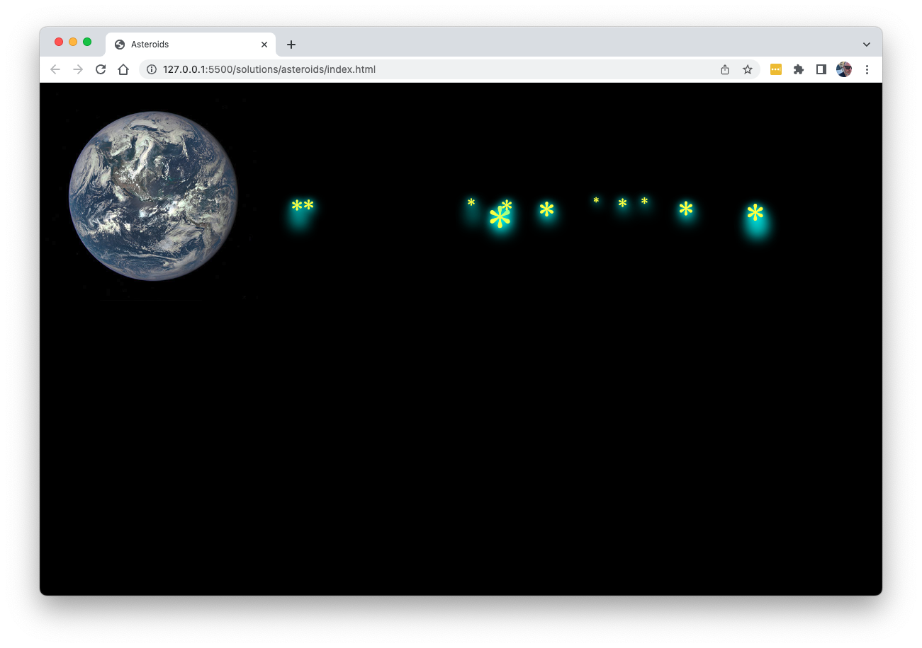

The DOM is an application programming interface or API for HTML documents. It represents elements as a tree structure. Imagine a tree turned upside down. The trunk of the tree (the parent node) has branches (child nodes of the parent). These branches may have more branches and so on and so forth. The objects or elements in the tree can be addressed and manipulated using methods. We will begin to write functions in JavaScript. These functions will use our variables, create asteroid elements, and append them HTML nodes in the DOM.

The HTML, CSS, and image you'll need have all been provided in starter/lab05 directory in this course's repository. Copy them into your project and take a look them to get familiar with them.

Once you've copied them over, open index.html in your browser and you'll see the planet Earth over the black background of space.

We will manipulate the DOM by writing functions.

1. Return to the JavaScript file and create an instance of Asteroid inside the map() function:

let asteroid = new Asteroid(hazardous, distance, speed, size);

1. Define a method in the Asteroid class called placeAsteroid().

This function will place the asteroids in the DOM.

placeAsteroid() {}

To create an asteroid, you need to create the element that the program will append to the DOM.

1. In the method body, write the following statement:

let asteroidElement = document.createElement('a').

The document object provides properties and methods to access all node objects. Calling createElement on document and pass the string 'a' as an argument creates an <a></a> (anchor) tag.

1. On the next line, call the .textContent() method on the asteroidElement variable and set this equal to '*'.

This changes the text content of the <a> element to *. Now, you have an asteroid in the shape of an asterisk. Here's what the placeAsteroid() method should look like now:

placeAsteroid() {

let asteroidElement = document.createElement('a');

asteroidElement.textContent = '*';

}

Next, you'll add a class, asteroid, to the asteroid element to style it. This class has already been defined inside the style.css file. Return to JavaScript and on a new line, write the variable asteroid and call the method className on it. Set this equal to the string 'asteroid'.

placeAsteroid() {

let asteroidElement = document.createElement('a');

asteroidElement.textContent = '*';

asteroidElement.className = 'asteroid';

}

The next step is to access an element of the DOM to which the new element will be appended. When an element is appended, it is appended to a parent element as a child of that element. The HTML document has a <div> with the id “solar-system” that will be the parent of the asteroid elements.

The document object model has a method called getElementById() that can be used to get the <div> with an id of “solar-system”.

1. Create a variable called solarSystem and set it equal to document.getElementbyId('solar-system').

This will give you the parent that you will append the asteroid elements to. Here's what placeAsteroid() should look like now:

placeAsteroid() {

let asteroidElement = document.createElement('a');

asteroidElement.textContent = '*';

asteroidElement.className = 'asteroid';

let solarSystem = document.getElementById('solar-system');

}

To append the asteroidElement to the solarSystem, define a private method named append with two parameters: parent and el.

The parent represents the element in the DOM that already exists on our page. The el represents the element which we will append to the parent. When we append el to the parent, our element is added as the last child of that parent node.

**Private methods can be created in JavaScript by prefixing the name of the method with #. A private function can only be called from within the object.**

1. Define a method named #append with parameters of parent and el. The appendChild() method is called on parent and takes el as an argument.

#append(parent, el) {

parent.appendChild(el);

}

1. Call the #append() method from inside the placeAsteroid() method.

placeAsteroid() {

let asteroidElement = document.createElement('a');

asteroidElement.textContent = '*';

asteroidElement.className = 'asteroid';

let solarSystem = document.getElementById('solar-system');

this.#append();

}

1. Pass the arguments solarSystem and asteroidElement to append().

The solarSystem variable represents the parent, so it is written first. The asteroidElement variable is the child or el, so it is written second.

placeAsteroid() {

let asteroidElement = document.createElement('a');

asteroidElement.textContent = '*';

asteroidElement.className = 'asteroid';

let solarSystem = document.getElementById('solar-system');

this.#append(solarSystem, asteroidElement);

}

Refresh index.html in your browser. Nothing will happen at this point, because placeAsteroid() hasn't been called yet.

1. Add a call to asteroid.placeAsteroid() at the end of the try block in the getAsteroids() method :

asteroid.placeAsteroid();

Right now, the program can create many asteroids, but they are all be the same distance from the earth and the visualization looks as though there is only one asteroid.

In the next steps, you'll add functions to visualize the speed, distance, size, and hazard data.

1. Define a method called #setDistance(). This function takes two arguments: asteroid and distance.

#setDistance(asteroidElement) {

}

This method will use the float value of the distance property to change the location of an asteroid element on the page by adjusting the style of the element. More specifically, it will adjust the margin-left property. It is currently set at 0px, which places the asteroid next to planet Earth. If you increase the value of the margin-left property it will move the element away from Earth.

1. Call .style on asteroidElement.

#setDistance(asteroidElement) {

asteroidElement.style

}

1. Chain .marginLeft after .style on the asteroidElement element.

#setDistance(asteroidElement) {

asteroidElement.style.marginLeft

}

The variables for distance range in millions of km so it will need to be scaled down for the visualization. Try dividing distance by 100000 and set the pixel size of the margin-left to this value.

1. Set asteroid.style.marginLeft equal to distance/100000.

#setDistance(asteroidElement) {

asteroidElement.style.marginLeft = this.distance/100000;

}

1. Concatenate ‘px’ onto distance/100000.

When 'px' is concatenated onto distance/100000, this entire value is coerced into a string. This string becomes the value for the margin-left property in the CSS DOM.

#setDistance(asteroidElement) {

asteroidElement.style.marginLeft = this.distance/100000 + 'px';

}

1. Call this.#setDistance(asteroidElement) in the placeAsteroid() function.

Now, each asteroid in the collection should have a property, margin-left, that has a value based on its distance from Earth.

You're not finished with styling the asteroid elements just yet, though. You still have to set the hazard, speed and size of the asteroids.

1. Start a new method named #setSize(). This method will style the CSS font-size property of each asteroidElement so that we can see their relative size.

#setSize(asteroidElement) {

}

1. Similar to setting the distance, call .style on asteroidElement, then chain .fontSize onto that. Set this all equal to size. Concatenate 'px' onto size.

#setSize(asteroidElement) {

asteroidElement.style.fontSize = size + 'px';

}

The size values range from single to triple digits(in meters). This means the font-size will be huge for some asteroids. This may be distracting, so we can add a conditional statement to this function. If the value of size is greater than a certain number, scale it down. Otherwise, let size remain the same.

1. In the #setSize method, before the font-size of asteroid is set, start a conditional statement:

#setSize(asteroidElement) {

if

asteroidElement.style.fontSize = this.size + 'px';

}

1. In parentheses, add the condition ( this.size > 100 ).

#setSize(asteroidElement) {

if ( this.size > 100 )

asteroid.style.fontSize = this.size + 'px';

}

1. After the condition and in curly brackets, write { this.size = this.size/10 }.

This reassigns the value of the size property to be a tenth of its original value.

#setSize(asteroidElement) {

if ( this.size > 100 ) {

this.size = this.size / 10

}

asteroidElement.style.fontSize = this.size + 'px';

}

1. Add this method to the #placeAsteroid()method and the asteroid elements will vary in size and distance.

#placeAsteroid() {

let asteroidElement = document.createElement('a');

asteroidElement.textContent = '*';

asteroidElement.className += 'asteroid';

this.#setSize(asteroidElement);

this.#setDistance(asteroidElement);

let solarSystem = document.getElementById('solar-system');

this.#append(solarSystem, asteroidElement);

}

Next up, speed! To visualize speed, we will add a motion blur that looks like tail for each asteroid. The faster ones should look like they’re traveling faster, and while asteroids generally don’t have tails, we will give them a longer motion blur which will appear like a longer tail.

To achieve this visualization, we will add a class written in CSS to each asteroid. If you look at the css file, you'll see that it contains three classes for adjusting the speed: .speed-low, .speed-medium, and .speed-high. The values of the text-shadow properties will differ in pixel length. By creating multiple shadows you can give the impression that faster asteroids show a longer tail (motion blur) than slower asteroids.

1. Define the method, #setSpeed() that will add these classes to the asteroid.

#setSpeed(asteroidElement) {

}

Speeds can be 10000 to over 100000km/hr. Let’s choose some integers within this range to add each class. For asteroids with speeds greater than 50000km/hr we add ‘speed-high’, greater than 25000 we add speed-medium, and all other speeds below 25000 we add speed-low. Therefore we will need more than one conditional statement.

To write multiple conditional statements that executes different code for different conditions you can use the if, else if, and else commands.

1. Write if ( speed > 50000 ) {} for the first condition in the #setSpeed method.

#setSpeed(asteroidElement) {

if ( this.speed > 50000 ) {

}

}

1. After the curly brackets of the first condition, write the second condition, else if ( this.speed > 25000 ) {}.

function setSpeed(asteroidElement) {

if ( this.speed > 50000 ) {

} else if ( this.speed > 25000 ) {

}

}

1. Write the keyword else and another set of curly brackets, {} after the second set of curly brackets. The code for this condition will be executed if the first two conditions are false.

function setSpeed(asteroidElement) {

if ( this.speed > 50000 ) {

} else if ( this.speed > 25000 ) {

} else {

}

}

Each condition will execute code that adds a class to the asteroid element. You can use the same method you used to add the 'asteroid' class to style the asteroidElement element , .className. Because the asteroid elements already have a class, you need to concatenate by using the '+=' operator and putting an extra space before the speed class string. If you used the = operator, you would overwrite the asteroid class.

1. Write asteroid.className += ' speed-high' for the code block of the first condition.

#setSpeed(asteroidElement) {

if ( this.speed > 50000 ) {

asteroidElement.className += ' speed-high';

} else if ( this.speed > 25000 ) {

} else {

}

}

1. Write asteroidElement.className += ' speed-medium' for the code block of the second condition.

#setSpeed(asteroidElement) {

if ( this.speed > 50000 ) {

asteroidElement.className += ' speed-high';

} else if ( this.speed > 25000 ) {

asteroidElement.className += ' speed-medium';

} else {

}

}

1. Write asteroidElement.className += ' speed-low' for the code block of the third condition, executed only if the first two conditions are found to be false.

#setSpeed(asteroidElement) {

if ( this.speed > 50000 ) {

asteroidElement.className += ' speed-high';

} else if ( this.speed > 25000 ) {

asteroidElement.className += ' speed-medium';

} else {

asteroidElement.className += ' speed-low';

}

}

1. Add the method call #setSpeed(asteroidElement) to the placeAsteroid() method. We can display our asteroid motion blurs!

#placeAsteroid() {

let asteroidElement = document.createElement('a');

asteroidElement.textContent = '*';

asteroidElement.className += 'asteroid';

this.#setSpeed(asteroidElement);

this.#setSize(asteroidElement);

this.#setDistance(asteroidElement);

let solarSystem = document.getElementById('solar-system');

this.#append(solarSystem, asteroidElement);

}

Next, we want to display whether or not the asteroid is a hazard. What is a good color to represent a hazardous object? Why not red? This function will add the hazardous class to our element depending on the whether the value of the isHazardous property is true or false.

1. In JavaScript, define a method named #setHazard(asteroidElement).

function setHazard(asteroidElement) {

}

1. Write a conditional statement and a block of code to run if isHazardous is true, if ( isHazardous === true ) { //execute code to add class }.

function setHazard(asteroidElement) {

if ( this.isHazardous === true ) {

//execute code to add class

}

}

1. Write asteroidElement.className += ' hazardous' in the conditional statement block of code. Remember the += operator and the space before the word hazardous in the string that represents the class.

#setHazard(asteroidElement) {

if ( this.isHazardous === true ) {

asteroidElement.className += ' hazardous';

}

}

1. Add a call to setHazard(asteroidElement) to the placeAsteroid() method.

#placeAsteroid() {

let asteroidElement = document.createElement('a');

asteroidElement.textContent = '*';

asteroidElement.className += 'asteroid';

this.#setSpeed(asteroidElement);

this.#setSize(asteroidElement);

this.#setDistance(asteroidElement);

this.#setHazard(asteroidElement);

let solarSystem = document.getElementById('solar-system');

this.#append(solarSystem, asteroidElement);

}

Now, potentially hazardous asteroids are red! One may feel a bit of anxiety knowing the distance, speed, size and hazard info of all these asteroids. What can we do about that? Let’s blow them up with JavaScript!

## PART IV - Events

We have received asteroid data from NASA and displayed those asteroids and their distance from Earth, speed, size and whether or not they are potentially hazardous. The next step to consider is how to interact with those asteroids and blow them up! To do this, we will add an event listener that will blow up the asteroid when the user clicks it.

1. Define a method named #targetAsteroid that takes an argument of asteroidElement,

#targetAsteroid(asteroidElement) {

}

1. Define another method named #boom(), outside the scope of the #targetAsteroid() method.

This is the function that will run when an asteroid element is clicked. Notice that it does not take an argument. Why do you think this is?

#boom() {

}

We will return to writing the code for #boom() at a later step.

1. Return to #targetAsteroid() and inside the method, write the asteroid element.

#targetAsteroid(asteroidElement) {

asteroidElement

}

1. Chain an event listener, .addEventListener() to the element.

#targetAsteroid(asteroidElement) {

asteroidElement.addEventListener();

}

The event listener method will take two arguments, an event that it “listens” for and a callback function to run when the event occurs. There are many types of events that can occur within a page. Each event is represented by an object. This object can have custom fields or functions to get additional information about that event. Events can represent anything from basic user interactions (such as clicking a mouse or a ‘click’ event) to things that occur upon rendering or loading the DOM.

1. Add the event 'click' as the first argument of the addEventListener function, addEventListener('click').

#targetAsteroid(asteroidElement) {

asteroidElement.addEventListener("click");

}

1. Add the function boom as the second argument to the addEventListener function, addEventListener('click', boom).

Notice that when we write this function as an argument, we leave off the parentheses (). The boom function is a callback function, run only when the event occurs. When the parentheses are added to the end of a function, this executes the functions. We want to reference our function, only to be executed when the event occurs, and therefore, we leave off the parentheses.

#targetAsteroid(asteroidElement) {

asteroidElement.addEventListener("click", this.#boom);

}

1. Return to defining the boom method. Add this to the function.

#boom() {

this

}

Inside boom(), this refers to the asteroidElement element that triggered it to run.

1. Chain .innerHTML on this.

This will allow us to access the inner HTML of our asteroid element. Our asteroid element is currently an <a> tag and inside that tag is an asterisk that represents the shape of an asteroid. We intend to change that.

#boom() {

this.innerHTML

}

1. Set this.innerHTML equal to a span containing the word 'BOOM!!!'. Use the = operator.

This will reassign the inner HTML of our asteroid ‘a’ tag from the string '*' to the explosion.

#boom() {

this.innerHTML = '<span class="boom">BOOM!!!</span>';

}

1. Add a call to targetAsteroid() to the placeAsteroid() function to set the event listener for each asteroid. For targetAsteroid to be able to set an event listener, the call to it must appear after the element has been inserted into the DOM (using the #append() method).

this.#targetAsteroid(asteroidElement);

Click on the asteroids and blow them up! BOOM!!! What an event! If you have time, think about other improvements you could make to this program. For example, how would you make the app animate asteroids or show a series of days? Can you make a spaceship that starts out at the middle of the screen that the user can control and use to destroy asteroids by shooting at them?

# Lab 06: Styling React

In this lab, you'll use Bootstrap to apply some global layout styles to the react-bookstore project, and you'll learn how to use style modules to add styles to individual components.

1. Install Bootstrap inside your **react-bookstore** project.

npm install --save bootstrap

1. Link to **bootstrap.css** inside of **src/main.jsx.**

import 'bootstrap/dist/css/bootstrap.css';

1. Change the <> and </> to <div> and </div> in **App.jsx**, and add the container class.

import Header from './Header.jsx';

import ProductList from './ProductList.jsx';

import Cart from './Cart.jsx';

import Footer from './Footer.jsx';

import './App.css';

function App() {

return (

<div className="container">

<Header />

<ProductList />

<Cart />

<Footer />

</div>

);

}

export default App;

1. Surround the ProductList and Cart components with a <div> with the class of "row". Create two columns in App.jsx using Bootstrap's responsive grid classes.

return (

<div className="container">

<Header />

<div className="row">

<div className="col-md-8">

<ProductList />

</div>

<div className="col-md-4">

<Cart />

</div>

</div>

<Footer />

</div>

);

1. Run npm test and make sure that your tests pass.
2. Run npm run dev to verify that your code builds. Your UI should now look like this:

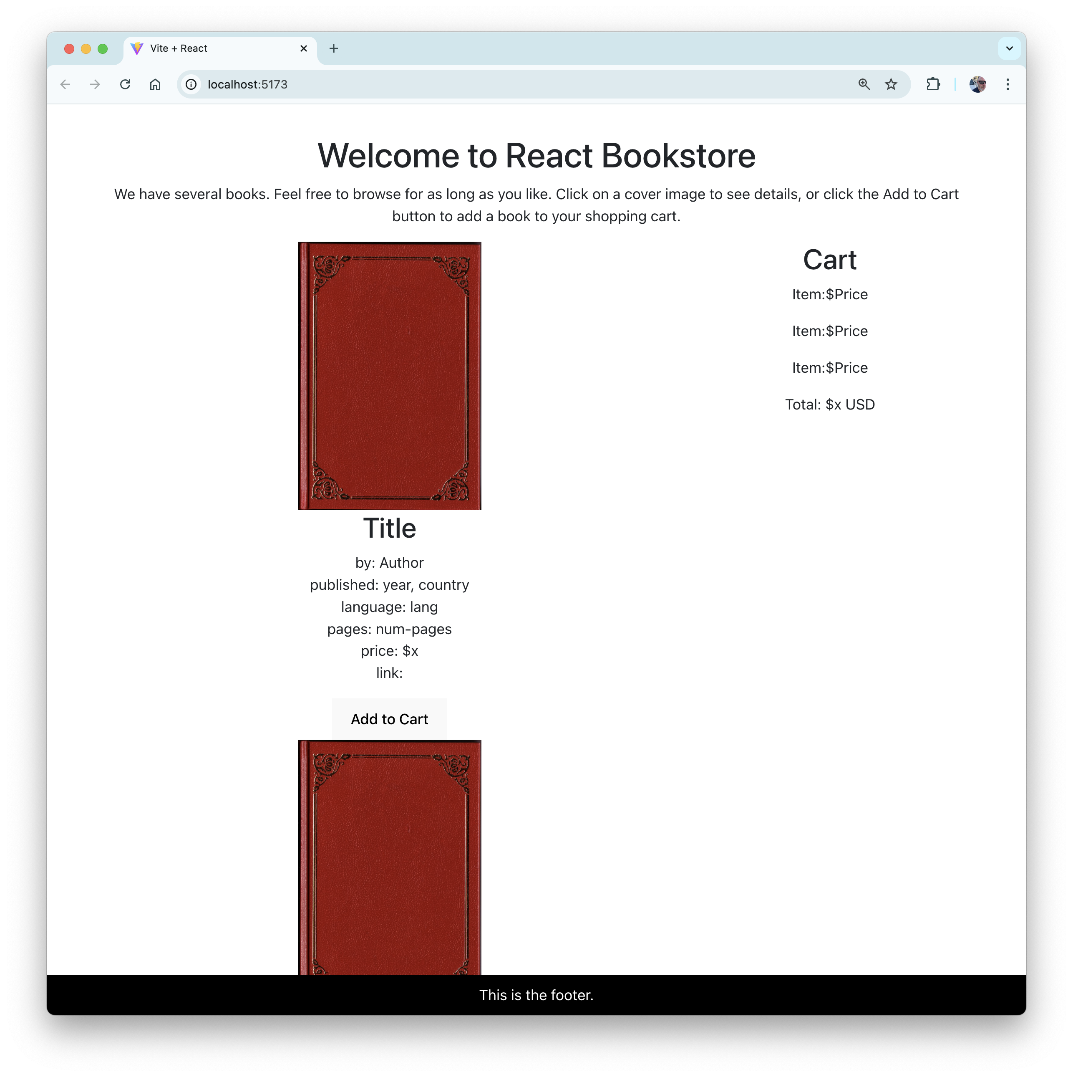

1. Modify your ProductList component to make each product an item in an unordered list.

<ul>  
 <li><Product /></li>  
 <li><Product /></li>  
</ul>

1. Create a new file in the **src** directory named **ProductList.module.css**.

This will be our first style module.

1. Inside **ProductList.module.css** create two styles, productList and productListItem.

.productList {

padding: 0;

display: flex;

flex-wrap: wrap;

justify-content: space-between;

align-items: stretch;

}

.productListItem {

list-style: none;

width: 32%;

}

These two styles will control the layout of the products inside the product list.

1. Import the style module into ProductList.jsx and give the module the name styles.

import styles from './ProductList.module.css';

1. Attach the styles to the appropriate elements.

<ul className={styles.productList}>

<li className={styles.productListItem}><Product /></li>

<li className={styles.productListItem}><Product /></li>

</ul>

1. Add as many additional <Product /> elements to the list as you want by copying and pasting additional lines in the return statement.
2. Preview the styled list in your browser.

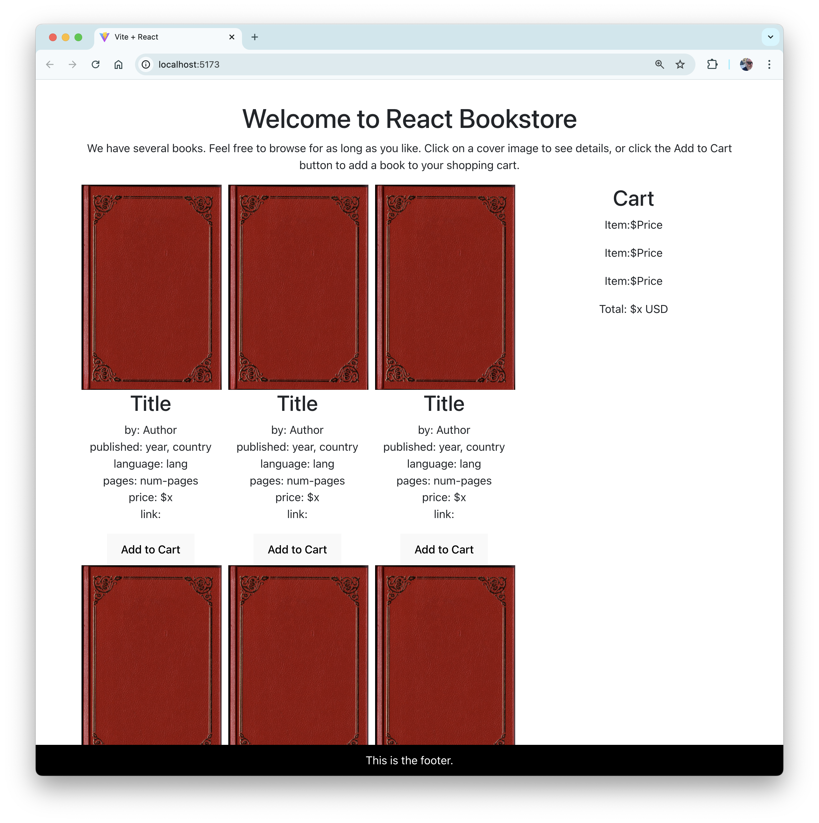

# Lab 07: Props and Containers

At this point, you should have a static and partially styled version of the application, built using the following React components:

App

Header

Footer

ProductList

Product

Cart

CartItem

In this lab, we'll reorganize our project to pass data to subcomponents via the props object.

1. Create a folder inside **src** named **components**
2. Move **Header.jsx**, **Footer.jsx**, **ProductList.jsx**, **Product.jsx**, **Cart.jsx**, and **CartItem.jsx**, along with their test suites and css files, into the **components** directory.

Going forward, you'll put any components that receive props from a page and render a part of a page in this folder.

1. Create another folder named **pages** and put **App.jsx** (and its tests and css) into it.

Going forward, you'll put components that have state and that correspond to 'pages' in this folder.

1. Import the data file into **App.jsx.**

import productsData from '../data/products.json';

1. Test that the JSON file was correctly imported by printing out one of its values. Inside the return statement of App.jsx, use the following code to write out the title of the first book in the data file:

{productsData[0].title}

1. If the data file was imported correctly, delete the testing code you wrote in the previous step.
2. Modify each of the subcomponents of App to accept a props object. For example, here's what the function header of the Product component should look like:

function Product(props) {

1. Pass productsData from the App component to the ProductList component as a prop called products.

<ProductList products={productsData} />

1. Update ProductList to loop over the products array and generate a Product for each element in the array, passing appropriate data to the Product components as props.

return(

<ul className={styles.productList}>

{props.products.map(product => (

<li key={product.id}

className={styles.productListItem}>

<Product {...product} />

</li>

))}

</ul>

);

1. Inside Product (outside of the return statement), deconstruct the props object into individual constants (to save yourself from having to type 'props.' repeatedly in the return statement.

const { title, author, published, country, lang, pages, image, url, price } = props;

1. Update Product to make use of the props passed to it to display data about each product.
2. Create a file named Product.module.css and import it into Product.jsx.

import styles from './Product.module.css';

1. Create a new style rule in **Product.module.css** called thumbnail and set properties to format the book thumbnail images.

.thumbnail{  
 width: 200px;  
 height: 293px;  
 object-fit: cover;  
}

1. Add a className attribute to the img element in Product. Your img element should look something like the following:

<img className={styles.thumbnail} src={image ? "images/" + image:"images/default.jpg"} alt={title} />

1. Run npm run dev. It should look like this:

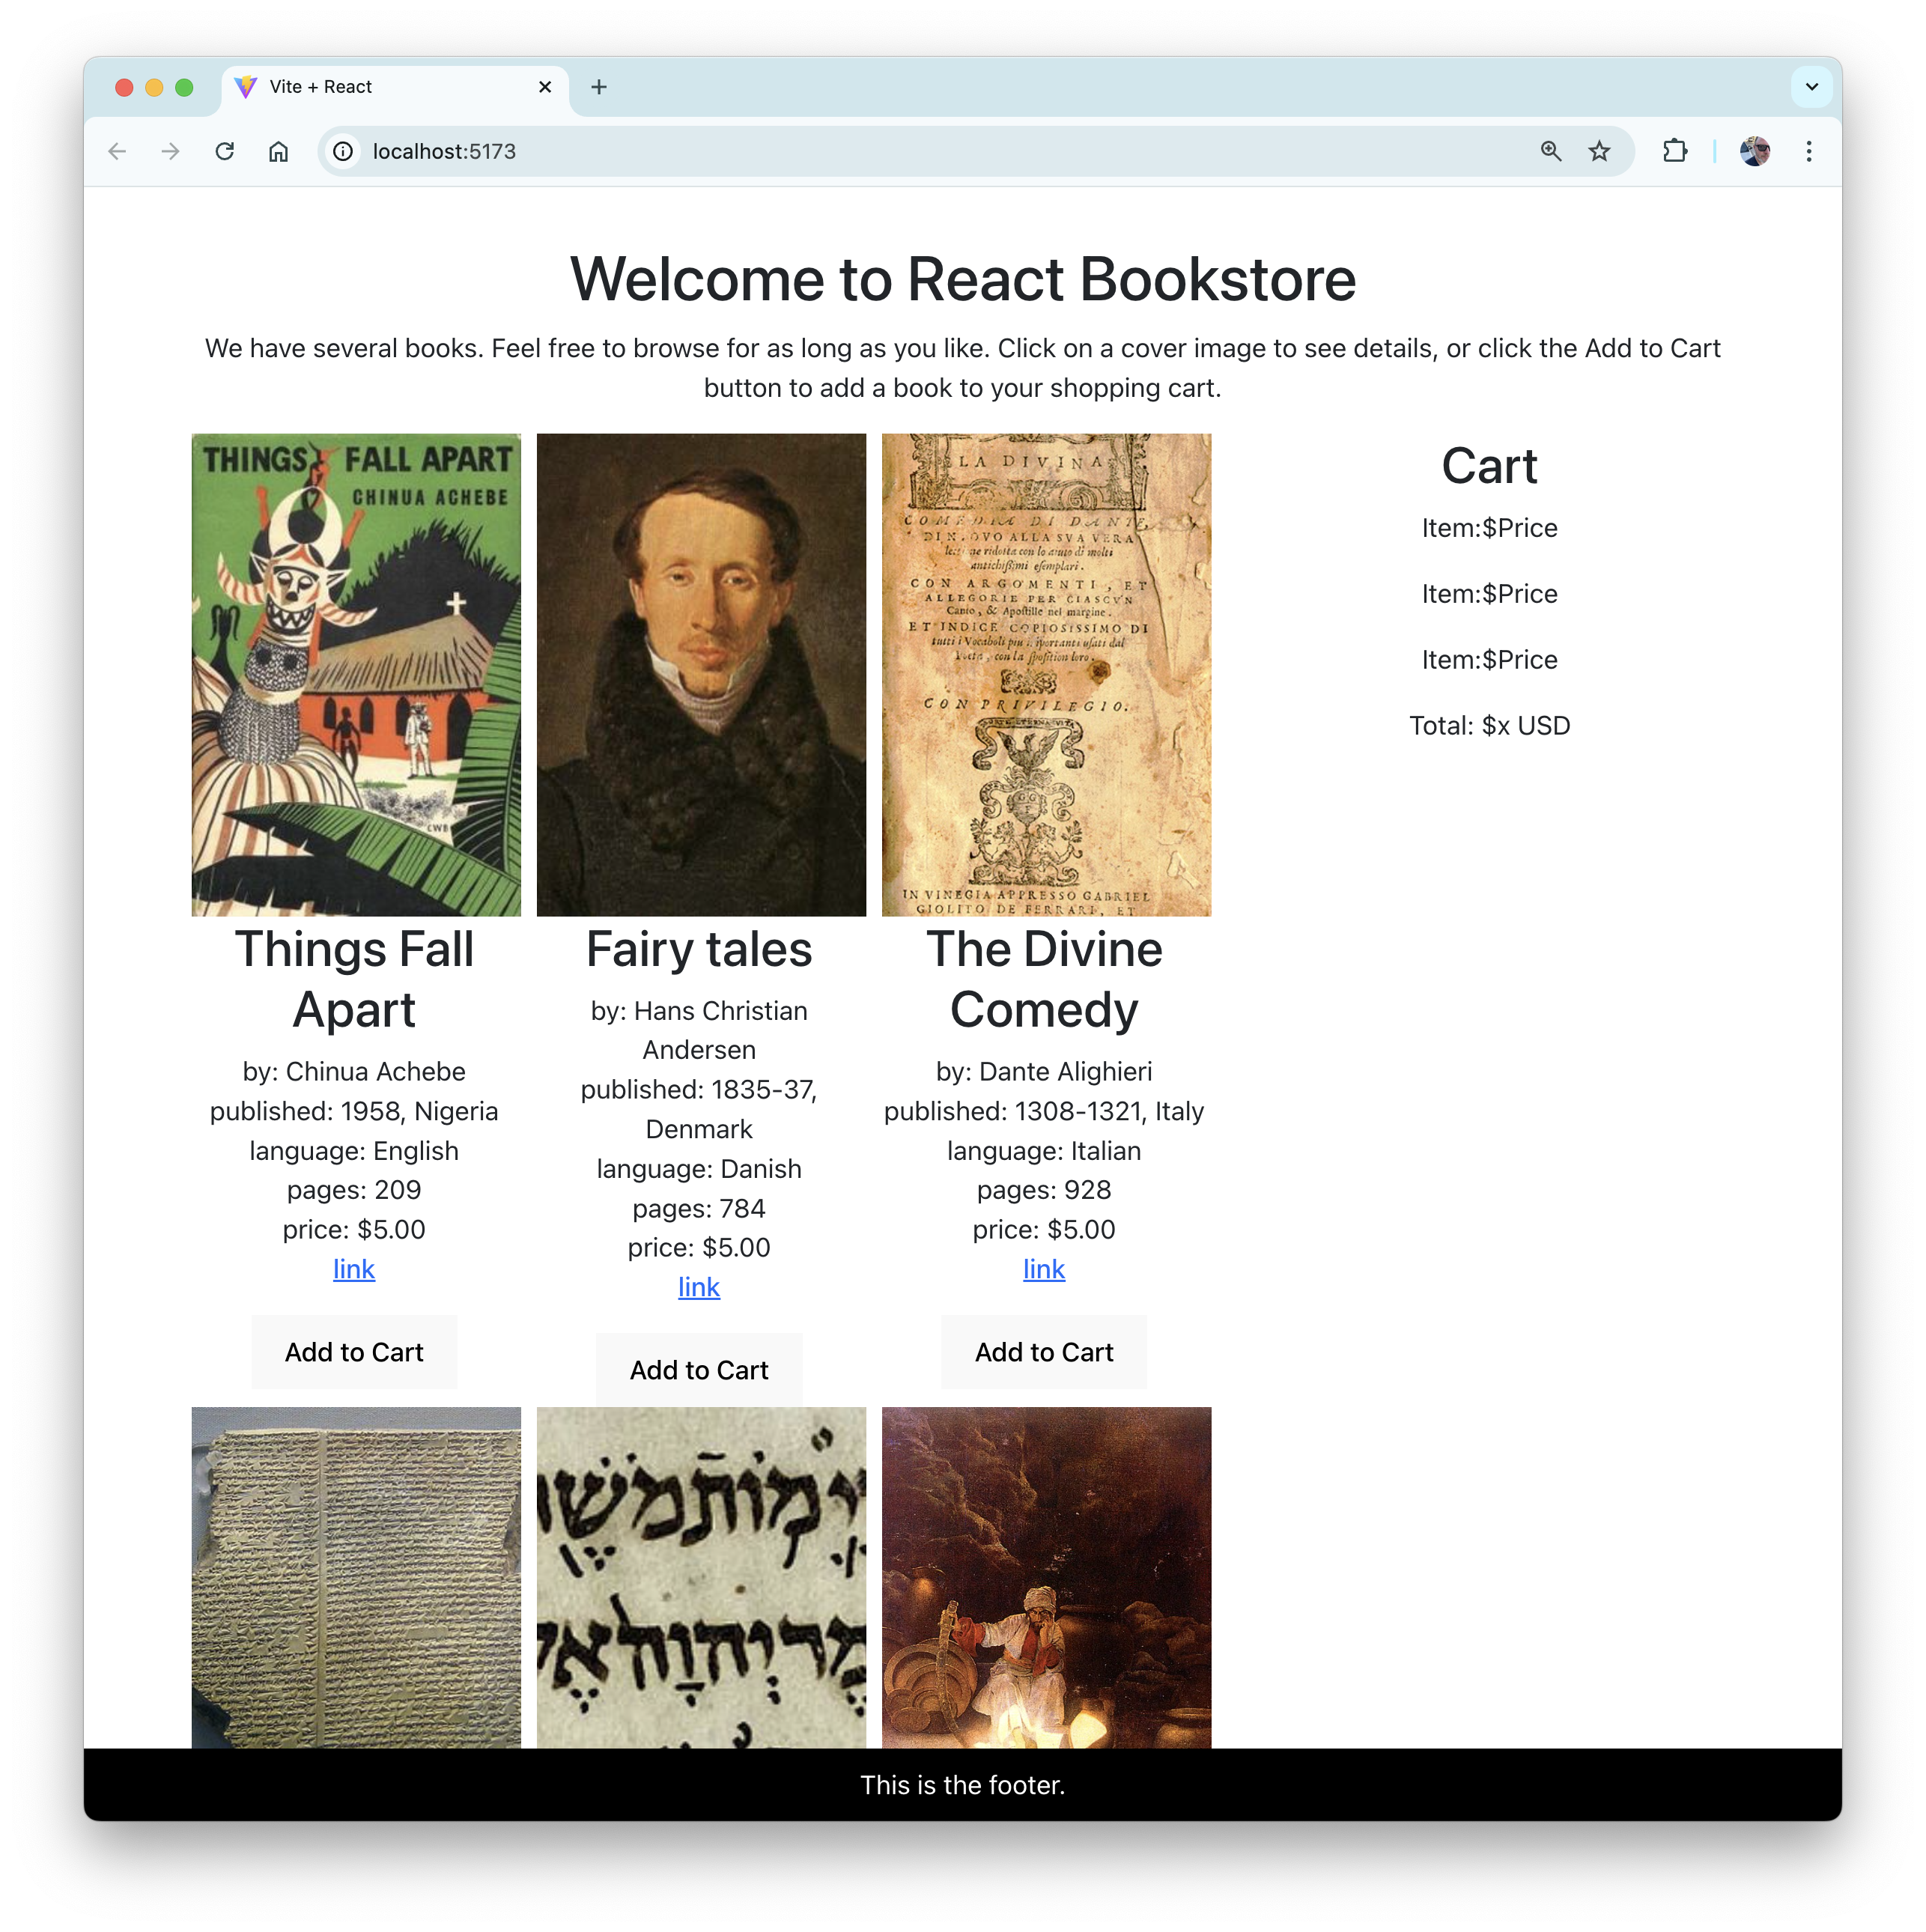

1. Run npm run test and notice that your tests for the ProductList and Product components are failing. Can you figure out how to make them pass? Think about it for a moment before moving on to the next step.

... thinking

...... still thinking

..........thinking some more

.............and some more

1. The testing framework renders components just like a browser does. If you don't provide the data that a component requires to render, the test will fail. To solve the problem, your tests need to pass the correct props to the component being tested.
2. In Product.test.js, create a mock product object inside the describe function (but above your test):

const book = {

id: '1',

title: 'Fake Title',

price: '10',

author: 'Author',

published: 'Published Date',

country: 'Country',

lang: 'Language',

pages: '100',

image: 'image.jpg',

url: 'Link URL',

inCart: false,

avgRating: '5',

}

1. Inside your test, use the spread operator to pass the all the properties of this book object to the Product component as props.

it('Renders', () => {

render(<Product {...book} />);

let element = screen.getByText(/Fake Title/i);

expect(element).toBeInTheDocument();

});

1. Use this same technique to fix the ProductList test.
2. Run npm run test to make sure your tests pass.

# Lab 08: Adding State

So far, we have a static version of the React Bookstore, built using components that pass data down using props. At this point, there's no way for the data to change or for users of the bookstore to add products to their cart.

State is the data in your application that makes your application interactive. The first step in adding state to a React application is to figure out what data needs to be part of the state object, and then to set this initial state and pass it down to the components that need it.

To determine what is state, think about what data changes in response to user input, isn't passed down via props, and can't be computed based on props.

Looking at the following screenshot of the finished store and shopping cart, what information fits this description?

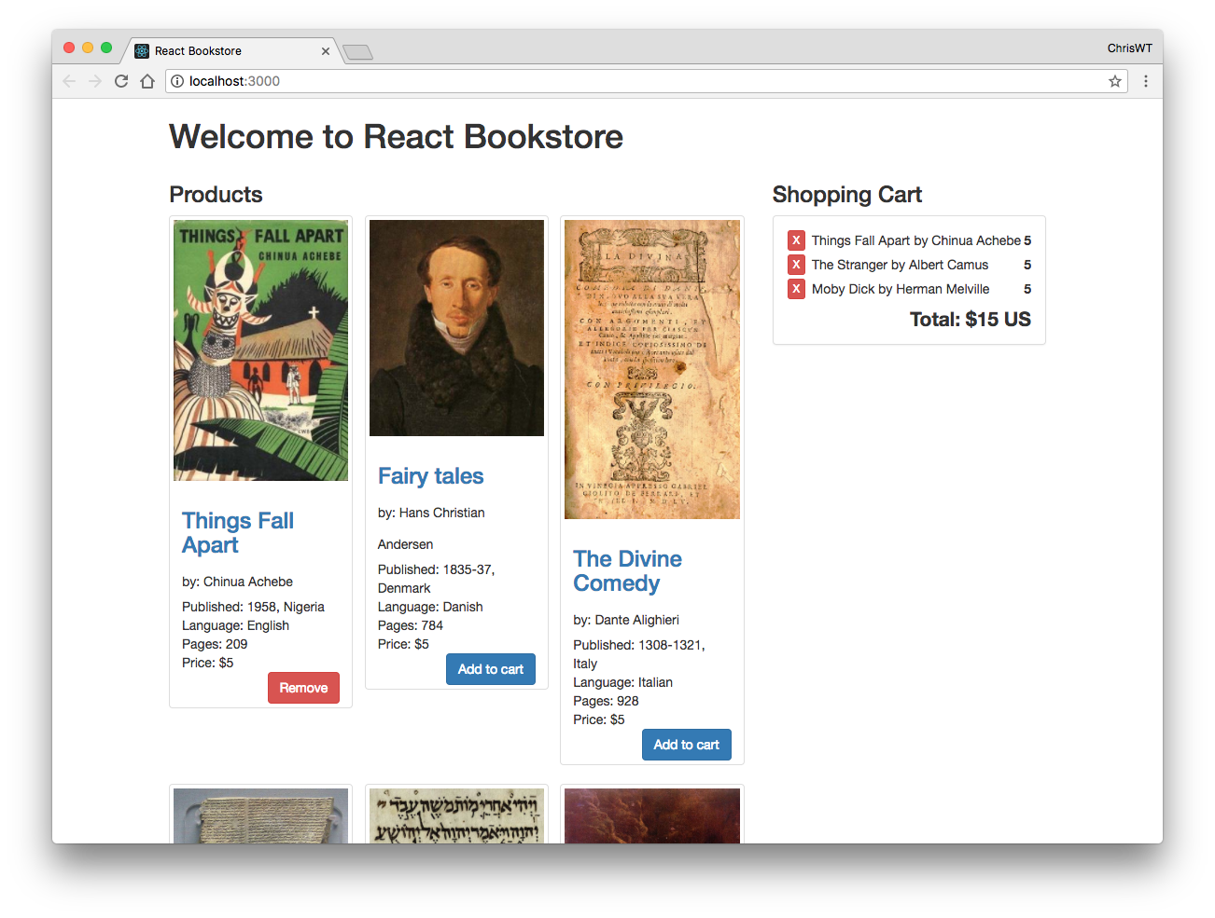

When you think you know, turn the page to see the answer.

In this React Bookstore application, the only thing that needs to be part of the state is the list of items that are currently in the shopping cart.

The next step in adding state to our application is to figure out where the state should live. Look again at the screenshot on the previous page. Which components need to know what's in the shopping cart?

If you said Cart and Product, you're correct.

To determine where the state should live, look for a component that is a common parent (or ancestor) to both Cart and Product. We only have one component that fits this description, App. So, we'll put the state into App.

Follow these steps to add state to the application.

1. Open **src/pages/App.jsx** in your code editor.
2. Import React.useState

import {useState} from 'react';

1. Create a state variable and setter function for itemsInCart and initialize it as an empty array.

const [itemsInCart,setItemsInCart] = useState([]);

1. Pass itemsInCart into the Cart component as props.

<Cart itemsInCart={itemsInCart} />

1. Add a product to the itemsInCart array, for testing. We'll only be using the id, title and price in the Cart (to start, anyway), so you can just pass those three.

const [itemsInCart,setItemsInCart] = useState([

{

"id": "1",

"title": "Things Fall Apart",

"price": "5"

}

]);

1. Pass itemsInCart to ProductList. We'll need that data in ProductList as well so we can show which products are already in the cart.
2. Inside the ProductList component, figure out how to pass a prop down to each product that is currently in the shopping cart and change the message on its button from **Add to Cart** to **In Cart**.

**Hint:** One way to do it is to create an array of just the ids from itemsInCart, then use the Array.includes() method to test whether each product's id is in the cart.

If you get stuck, look at the solution inside **intro-to-react/solutions/lab08**.

1. Render the list of cartItems inside the Cart component.
2. Modify the CartItem component to display the name and price of the item.
3. Calculate the total price of all the items in the shopping cart and display it in the Cart component.

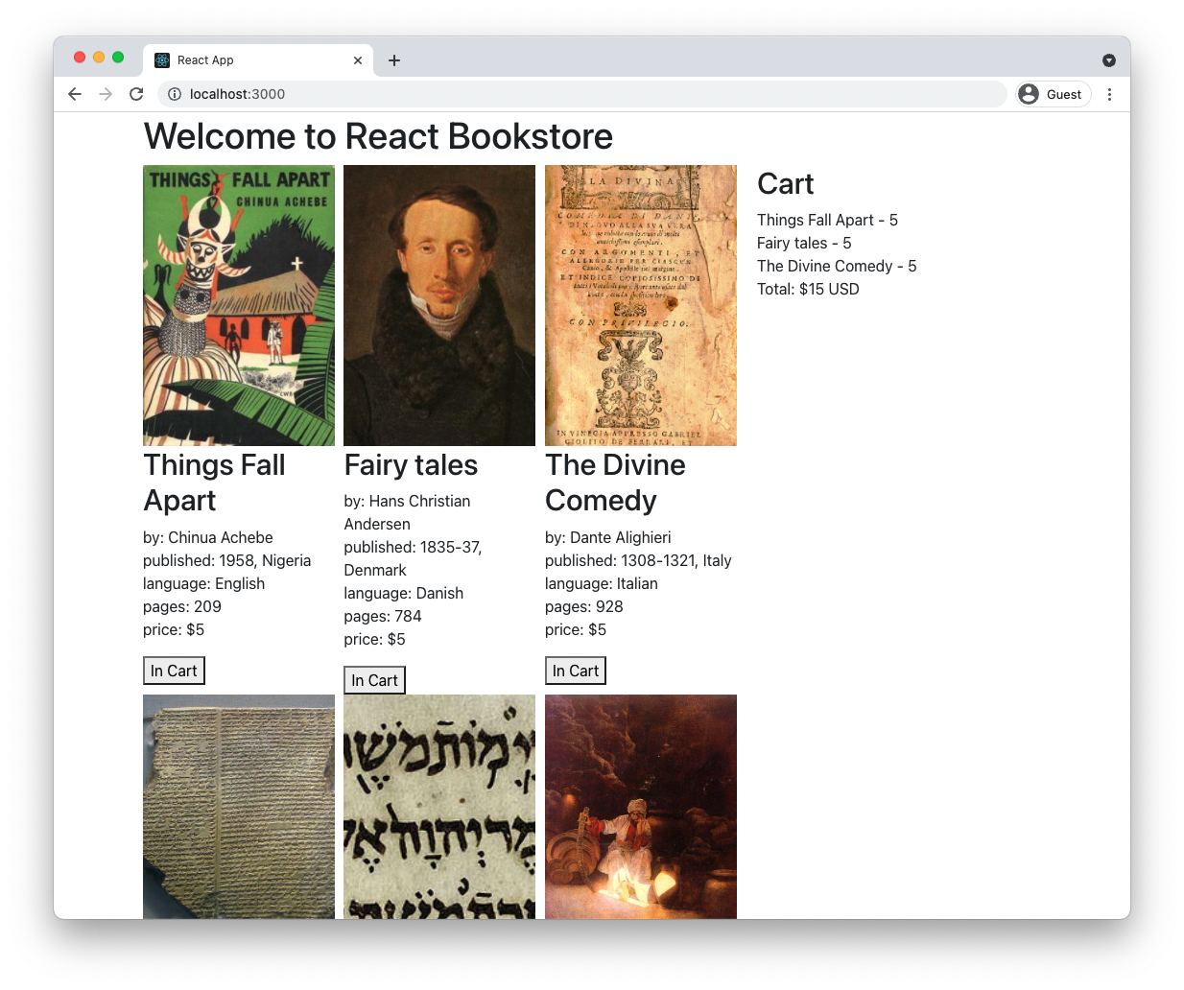

1. Run your tests. Notice that ProductList and Cart are failing. Can you figure out how to fix them?
2. Can you improve any of your other tests, such as CartItem?

# Lab 09: Interactions, Events, and Callbacks

User interactions happen when a user clicks a button, moves their mouse, enters text into a form, interacts with a touch screen, and so forth. These interactions trigger events in the web browser (or another user agent), which can be listened for and responded to using JavaScript.

In addition to user interactions, many other things trigger events that can be listened for and responded to.

## React's Synthetic Events

Over the years, web browsers have developed slightly different ways of handling events. To eliminate these differences, it's common for JavaScript libraries and frameworks to wrap the browser's native events in a cross-browser abstraction layer. React's cross-browser event handling system is called **Synthetic Events**.

Except for the fact that it works the same in every browser and some React-specific properties, Synthetic Events work the same as the native browser events.

## Unidirectional Data Binding

Unlike many other JavaScript frameworks and libraries, React doesn't feature 2-way data binding. What this means is that changes to the model in a React application (i.e. the state object) trigger updates to the view, but changes to the view don't automatically update the model. This one-way data flow makes it easier to test and reason about React applications, but it is also the cause of one of the trickiest parts of React to understand.

In this lab, you'll learn about passing functions from parent components to child components and you'll learn how to call functions to update the state of a React view.

## State in a Class Component

Class components are components created by extending the React.Component class. Although almost everything in React can be done using function components, understanding class components will give you a deeper understanding of how React works, and it will also enable you to use the features and techniques in React that aren't accessible using function components.

To create a class component, import React into your module and then extend React's Component class.

import React from 'react';

class MyComponent extends React.Component {

...

}

A JavaScript class can have a constructor method, which will only run once during the lifecycle of the component. The constructor is used to initialize the state object and to bind functions to the class. The constructor method is optional, but if you do use it, you must call the super() method as the first thing inside constructor. The super() method calls the constructor of the parent class. You should also pass the props object to super().

import React from 'react';

class MyComponent extends React.Component {

constructor(props){

super(props);

this.state = {

...

}

}

...

}

export default MyComponent;

The rest of a component may contain any number of methods, but one method, render() must be present. The render() method of a class component is essentially the same as a function component. The render method has a return statement that uses JSX to define the part of the user interface the component is responsible for.

import React from 'react';

class MyComponent extends React.Component {

constructor(props){

super(props);

this.state = {

...

}

}

render(){

return (<h1>Welcome to my component.</h1>);

}

}

export default MyComponent;

The state object, which can be initialized in the constructor of a class component, holds the stateful properties of a component. When these properties change, React re-renders the component. The reason React knows to re-render the component when the state object changes, is because the developer only changes the state object using React's setState() method.

So, the first key to understanding how to create dynamic user interfaces with React is to understand React's setState() method.

The setState() method takes as its argument an object representing a change to the state object. Calling setState() also triggers the render() method, which causes the component and its children to be updated in the browser to reflect the new data.

In our application, the state consists of an array of products. In the previous lab, we set the initial state of the application to an array containing a single product. If another item were added to the cart, you might consider using an array method to update the state and then use setState() to trigger the re-rendering, like this:

this.state.items.push(newItem); // <=== don't do this

this.setState({items: this.state.items});

However, in React, state should be treated as immutable. What this means is that you should never perform operations on the state object directly, except in the component's constructor.

Directly manipulating the state object can cause problems with the rendering and lifecycle methods in React.

Instead, you should use the setState() method, which accepts as its argument an object to be merged into the state. For example, if you set the initial state in the constructor, like this:

constructor(props){

super(props);

this.state = {items: [], isVisible:false}

}

You can mutate the state outside of the constructor by creating an object containing the property or properties that you want to change and passing it into the setState method.

this.setState({

items: [...this.state.items, newItem]

});

This example uses the spread operator to split the items array into separate values. You can then add the new item to the end of the array and update state.items without mutating the state object directly.

If you want to remove an item from an array in the state object, one way to do it is by knowing the position of the element you want to remove. You can then create a new array without the item in question, using the following code:

let newData = this.state.data.slice(); //copy array

newData.splice(index, 1); //remove element

this.setState({data: newData}); //update state

Another way to remove an item from an array is by using the Array.filter method, like this:

let newData = this.state.data.filter(  
 id => id !== idToRemove); //filter out a value

this.setState({data: newData}); //update state

Now that you understand how to update the state in React class components, the next thing to understand is how child components can call functions that affect the state of the parent component.

The key is in the bind() function. The job of bind() is to create a new function that has the this keyword set to a specific value, and with a list of arguments passed to the new function when it's called.

In React, we use bind() to create a function in one component that can be called in response to an event in another component but that will affect the original component.

To see how this works in practice, follow these steps to add interactivity to the React Bookstore user interface.

1. Convert **App.jsx** into a class component, following these steps:
   * Import React
   * Change the function header to a class header.
   * Create a constructor
   * Call the super() method
   * Initialize the this.state object in the constructor, with one property, itemsInCart
   * Delete the call to useState(), along with the import of useState()
   * Create a render method and copy the existing return statement from the function component.
   * In the return statement, reference itemsInCart using this.state.itemsInCart

Your App component should now match the following:

import {Component} from 'react';

import Header from './Header'

import Footer from './Footer';

import ProductList from './ProductList';

import Cart from './Cart;

import './App.css';

import productsData from '../data/products';

class App extends Component {

constructor(props){

super(props);

this.state = {

itemsInCart: [

{

id: '1',

title: 'Things Fall Apart',

price: '5',

},

]

}

}

render(){

return (

<div className="container">

<Header />

<div className="row">

<div className="col-md-8">

<ProductList

itemsInCart={this.state.itemsInCart}

products={productsData}

/>

</div>

<div className="col-md-4">

<Cart itemsInCart={this.state.itemsInCart} />

</div>

</div>

<Footer />

</div>

);

}

}

export default App;

1. Create the following method inside the App component.

addToCart(product) {

let newItems = [...this.state.itemsInCart, product];

this.setState({

itemsInCart: newItems,

});

}

It's possible now to call the addToCart function from within the App component by using this.addToCart(). However, what we want to do is to call addToCart() in response to a click on the button in the Product component.

To make it possible to call the function with the context of the App component, we need to bind it.

1. Add the following inside of the constructor for the App component to create a new function that's explicitly bound to App.

this.addToCart = this.addToCart.bind(this);

1. Pass the bound addToCart function down to the ProductList component as a prop.

<ProductList

addToCart={this.addToCart}

itemsInCart={this.state.itemsInCart}

products={productsData} />

1. Open the ProductList component and pass the addToCart function to the Product components as a prop.
2. Inside the Product component, create a new function, called handleClick. The job of this function will be to call the addToCart function, passing it an object containing the id, title, and price of the current Product.

function handleClick() {

props.addToCart({id:id,title:title,price:price});

}

1. Call the handleClick function as the event handler for the click event on the button.

<button

onClick={handleClick}>  
 {props.inCart?"In Cart":"Add to Cart"}  
</button>

1. Run **npm run dev** and test out your application.
2. Make clicking on the button when it displays the "In Cart" message remove the product from the cart.

Here's a function you can use to do the removal of items:

removeFromCart(idToRemove) {

let newItems = this.state.itemsInCart.filter((item) => item.id !== idToRemove);

this.setState({ itemsInCart: newItems });

}

1. Run your tests to make sure they still work, and fix them if not.

# Lab 10: Component Lifecycle and AJAX

Right now, the bookstore retrieves product data from a local file and displays all the books in the order in which they're in the array. But, what if you want to retrieve the data from the web and display in a random order (or, better, according to some algorithm, such as which books the user is most likely to buy or a user-chosen filter) each time a visitor comes to the store?

You could change the order of the items inside the ProductList component, but this has unintended consequences. Try the following to find out what happens.

1. Add the following function inside the ProductList component:  
   function shuffleArray(array) {  
    for (let i = array.length - 1; i > 0; i--) {  
    let j = Math.floor(Math.random() * (i + 1));  
    let temp = array[i];  
    array[i] = array[j];  
    array[j] = temp;  
    }  
    return array;  
   }
2. Create a new array by sorting the one passed as a prop.

let sortedProducts = shuffleArray(props.products);

1. Replace the array used for displaying the products with the new randomly sorted array.

{sortedProducts.map(product => (

1. Run npm run dev, and try adding some products to the cart.

Notice that the order of the cart changes every time you click a button. Clearly this is not what we want.

One way to fix this problem is to use React's componentDidMount() lifecycle method to only sort the products once, after the component has mounted. To do this, follow these steps:

1. Create a method named componentDidMount() in the App component.
2. Copy the shuffleArray method from ProductList and paste it into the App component (modifying it to use method notation if your App component is a class component).
3. Revert the ProductList component to how it was before you made the previous changes.
4. In App's componentDidMount method, call this.shuffleArray() and pass in the productsData.

this.shuffleArray(productsData);

1. Run npm run dev and notice what happens when you click one of the AddToCart buttons. Can you explain why this happens?

What's happening is that the productsData is loading before the App component is mounted. So, the initial render of the component uses the default sorting of the array, but the componentDidMount method is shuffling the array after the component finishes mounting. The result is that the next re-render of the component will causes it to display the products in their shuffled order.

To fix this, we can load the productsData in the componentDidMount lifecycle method. We'll do so using the fetch method.

1. Add a property named products with a default value of an empty array ([]) to the state object.
2. Add a property named loading with a default value of false to the state object (in the constructor).
3. Remove the import of the product data.
4. Pass this.state.products to the ProductList component instead of productsData.
5. Move src/data/products.json to public/data/products.json. Tip: Make sure to remove the data folder from src, or it will cause you problems later on.
6. Confirm that the json file is in the right place by visiting the following url in your browser: **http://localhost:5173/data/products.json**
7. Inside componentDidMount, use the fetch method to load the product data, sort it, and then update the state:

componentDidMount() {

this.setState({loading:true});

fetch('//localhost:5173/data/products.json')  
 .then(response => response.json())  
 .then(data => this.shuffleArray(data))  
 .then(data => {  
 this.setState(

{products:data,loading:false})  
 })  
};

1. Make a loading message display on the page when loading === true. One way to do this is by short-circuiting the return statement. Here's how that works:

if(this.state.loading){

return <p>Loading...</p>

} else {

// insert normal return statement here

}

1. Run npm run dev
2. Run your tests. The test for App will fail. Do you see why? Check the debug messages in the terminal where you're running Vitest.

What's happening is that when the testing framework is rendering the test, it doesn't have access to the URL where the data file is. This is fine, because it's a best practice to make a stand-in for any network requests or external dependencies needed for tests (a mock). However, fixing this is a bit more complicated than fixing previous testing errors because retrieving the data is an asynchronous process that the test runner (Vitest) will need to know about.

You learn about Vitest in an upcoming lab. For now, copy the App.test.jsx file from the solutions folder into your /pages folder and see if you can figure out how it works.

# Lab 11: Converting App to a Function Component

In this lab, we'll use the useEffect and useState hooks to convert App back to a function component.

1. Open App.jsx in your code editor and modify the import from 'react' to import useState and useEffect (instead of Component).
2. Change the class header to a function header. Since this is the root component, the function doesn't need to take props as a parameter.
3. Delete the constructor method.
4. Use useState to initialize the three state variables.

const [itemsInCart, setItemsInCart] = useState([]);

const [products, setProducts] = useState([]);

const [isLoading, setLoading] = useState(false);

1. Rewrite the componentDidMount method using useEffect and async functions.

useEffect(() => {

async function fetchData() {

try {

setIsLoading(true);

const response = await fetch(

'http://localhost:5173/data/products.json'

);

const json = await response.json();

const shuffledArray = shuffleArray(json);

setProducts(shuffledArray);

setIsLoading(false);

} catch (e) {

console.error(e);

}

}

fetchData();

}, []);

1. Shuffle the product data array before the products state array is updated.
2. Convert the functions written using method syntax to use the function keyword or arrow functions.
3. Change setState in the addToCart and removeFromCart functions to use setItemsInCart, and change the references to this.state to refer to the stateful itemsInCart variable.
4. Take the return statement out of the render method and delete the render method.
5. Update references to this in the return statement.
6. Start the app and fix any errors that occur.

# Lab 12: Creating and using a color theme context

React's Context API gives you a way to bypass passing data via props. Context is useful for data that's needed in many different components or that are deeply nested in the component hierarchy. In this lab, you'll create a color theme switcher.

1. **Create a new folder named context inside src.**
2. **Create** a new file named ThemeContext.jsx in your src/context directory.
3. Import createContext and useState into ThemeContext.jsx.

import { createContext, useState } from 'react';

1. Use the createContext function to create a new context.

const ThemeContext = createContext();

1. Create a provider component that will hold the state for the theme and provide it to the rest of the app.

const ThemeProvider = ({ children }) => {

const [theme, setTheme] = useState('light');

const toggleTheme = () => {

setTheme((prevTheme) => (prevTheme === 'light' ? 'dark' : 'light'));

};

return (

<ThemeContext.Provider value={{ theme, toggleTheme }}>

{children}

</ThemeContext.Provider>

);

};

export { ThemeProvider, ThemeContext };

1. In your main.jsx file, wrap your app with the ThemeProvider to make the theme context available throughout the app.

import React from 'react';

import ReactDOM from 'react-dom/client';

import { ThemeProvider } from './context/ThemeContext';

import App from './components/App.jsx';

import './index.css';

import 'bootstrap/dist/css/bootstrap.css';

ReactDOM.createRoot(document.getElementById('root')).render(

<React.StrictMode>

<ThemeProvider>

<App />

</ThemeProvider>

</React.StrictMode>

);

Now you can use the ThemeContext in any component by importing the useContext hook and the ThemeContext. Let's try it with the footer.

1. Import useContext and ThemeContext into Footer. jsx.

import React, { useContext } from 'react';

import { ThemeContext } from './ThemeContext';

1. Inside Footer(), pass the ThemeContext to useContext and destructure it to get the theme and the toggleTheme function.

const { theme, toggleTheme } = useContext(ThemeContext);

1. Modify the footerStyle object to switch the backgroundColor and the color properties between white and black based on the value of theme.

const footerStyle = {

backgroundColor: theme === 'light' ? 'white' : 'black',

color: theme === 'light' ? 'black' : 'white',

padding: '10px',

position: 'fixed',

left: '0',

bottom: '0',

margin: '0',

width: '100%',

};

1. Add a button to the footer that will toggle the theme:

return (

<p style={footerStyle}>

This is the footer.

<button onClick={toggleTheme}>Toggle Theme</button>

</p>

);

1. Run npm run dev and test it out!
2. See if you can figure out how to modify the theme of other components when you toggle the theme using the button in the Footer.
3. Run your tests and notice that the tests for App and Footer fail. To fix them, you need to import the ThemeProvider into their test files and wrap the element you're rendering with it, for example:

describe('Footer Component', () => {

it('Renders', () => {

render(<ThemeProvider><Footer /></ThemeProvider>);

let element = screen.getByText(/footer/i);

expect(element).toBeInTheDocument();

});

});

# Lab 13: Custom Hooks

Custom hooks aren't a built-in feature of React. Instead, they're a technique. A custom hook is a function that's uses other hooks (such as useState and useEffect) to make reusable functionality available to components.

Follow these steps to create a custom hook to simplify the process of using the ThemeContext.

1. Open contexts/ThemeContext.jsx
2. Import useContext from react.
3. After the export statement for the ThemeProvider create a new module for the theme hook:

export const useTheme = () => {

const context = useContext(ThemeContext);

if (!context) {

throw new Error('useTheme must be used within a ThemeProvider');

}

return context;

};

1. Remove the imports of useContext and ThemeContext from Footer.jsx and replace it with the import for useTheme():

import {useTheme} from '../contexts/ThemeContext';

1. Remove the call to useContext and replace it with a call to useTheme():

const { theme, toggleTheme } = useTheme();

1. Run npm run dev and test it out.

Hooks that aren't connected to Context are usually kept in a folder in src named hooks. For example, you could create a custom hook from the fetchData() function in App.jsx or from the shuffleData function. Doing so will simplify App and potentially make this functionality available to other components that may need it.

1. Create the src/hooks folder.
2. Create a new file in /hooks named useBooks.js

Notice that hooks aren't typically named with .jsx. This is because they don't return JSX.

1. Try to extract the fetchData functionality from App.jsx into a function named useBooks() that returns an array containing the products array and the isLoading status.

Check the solution file if you need help!

1. Remove the useState() and useEffect function calls from App.
2. Import useBooks() into App.jsx and use it to get the values of products and isLoading.
3. Challenge: Create a useCart() hook that exports the itemsInCart array, the addToCart function, and the removeFromCart function.

# Lab 14: Converting to TypeScript

In this lab, you'll convert the React bookstore to use TypeScript.

1. Install Typescript

npm install typescript --save-dev

1. Install types for React and ReactDom

npm install @types/react @types/react-dom --save-dev

1. In package.json, modify the dev and build scripts to compile the Typescript before running the app:

"dev": "tsc && vite",

"build": "tsc && vite build",

1. Create a file named tsconfig.json at the root of your project, with the following content:

{

"compilerOptions": {

"target": "ESNext",

"useDefineForClassFields": true,

"lib": ["DOM", "DOM.Iterable", "ESNext"],

"allowJs": true,

"skipLibCheck": true,

"esModuleInterop": false,

"allowSyntheticDefaultImports": true,

"allowImportingTsExtensions": true,

"strict": true,

"forceConsistentCasingInFileNames": true,

"module": "ESNext",

"moduleResolution": "Node",

"resolveJsonModule": true,

"isolatedModules": true,

"noEmit": true,

"jsx": "react-jsx"

},

"include": ["src"]

}

1. Rename App.jsx to App.tsx and update the link to App from main.js.

You should now see a lot of red underlining in VS Code.

1. Create a new folder named types inside src.
2. Make a file in types named book.tsx and create an interface for Book:

export interface Book {

id: string;

title: string;

author?: string;

published?: string;

country?: string;

lang?: string;

pages?: string;

image?: string;

url?: string;

price: string;

}

1. Import the Book type from types/book.tsx into App.tsx.
2. Assign types to any state variables that you haven't extracted into custom hooks yet:

const [itemsInCart, setItemsInCart] = useState<Array<Book>>([]);

1. Assign types to the parameters of addToCart and removeFromCart. For example:

function addToCart(product: Book) {

1. Test out the app to make sure it still works.
2. Rename ProductList.jsx to ProductList.tsx
3. Install the CSS modules typescript plugin

npm install typescript-plugin-css-modules --save-dev

1. Rename Footer.jsx to Footer.tsx
2. Add the following import to Footer.tsx:

import { CSSProperties } from 'react';

1. Annotate footerStyle using the CSSProperties interface:

const footerStyle:CSSProperties =

1. Add the css modules typescript plugin to the compilerOptions object in tsconfig.json:

"plugins": [{ "name": "typescript-plugin-css-modules"}]

1. Create a new file named Globals.d.ts inside src, with the following content:

declare module '*.module.css';

1. Create a new file in /types named product.ts and make an interface called ProductProps that contains the props received by ProductList.

import { Book } from './book';

export type ProductProps = Book & {

inCart: boolean;

addToCart: (product: Book) => void;

removeFromCart: (id: string) => void;

};

Function types in the interface need to have their parameters and return values. If the function doesn't return anything, use void. For example:

addToCart: (id: string) => void;

1. Import ProductProps into ProductList and specify the type of the props object received by ProductList:

function ProductList(props: ProductProps) {

1. Convert the rest of the components to TypeScript.

# Lab 15: Testing with React Testing Library

In this lab, you'll use Vitest and React Testing Library to write more tests for your components.

1. Create a new directory outside of src and name it tests. Create a new file named setup.ts in tests with the following content:

import '@testing-library/jest-dom/vitest';

import { cleanup } from '@testing-library/react';

import { expect, afterEach } from 'vitest';

afterEach(() => {

cleanup();

});

1. Create a file named vitest.config.ts at the root of your project, with the following content:

import { defineConfig } from 'vitest/config';

import react from '@vitejs/plugin-react';

import tsconfigPaths from 'vite-tsconfig-paths';

export default defineConfig({

plugins: [react(), tsconfigPaths()],

test: {

globals: true,

environment: 'jsdom',

setupFiles: './tests/setup.ts',

coverage: {

enabled: true,

include: ['src/**/*.{js,jsx,ts,tsx}'],

exclude: ['src/generated/**/*.ts'],

reporter: ['text', 'html'],

},

},

});

1. Install some dependencies.

npm install --save-dev @vitejs/plugin-react

npm install --save-dev @vitest/ui

npm install --save-dev vite-tsconfig-paths

1. Modify your test script in package.json:

"test": "vitest --ui",

1. Run npm test in the root of your project. The results will appear in the terminal and the vitest ui will open in a browser window.

You probably already have some basic tests that you created in previous labs. However, because of changes to the components you’re testing, your tests may not all pass.

1. Update your existing tests so they all pass. You may need to use different methods from React Testing Library. Reference the testing library cheatsheet at the following URL to find additional queries to use:

https://testing-library.com/docs/react-testing-library/cheatsheet

1. When all your tests pass, you'll see a coverage report in the terminal, and you can access a coverage report in Vitest UI.

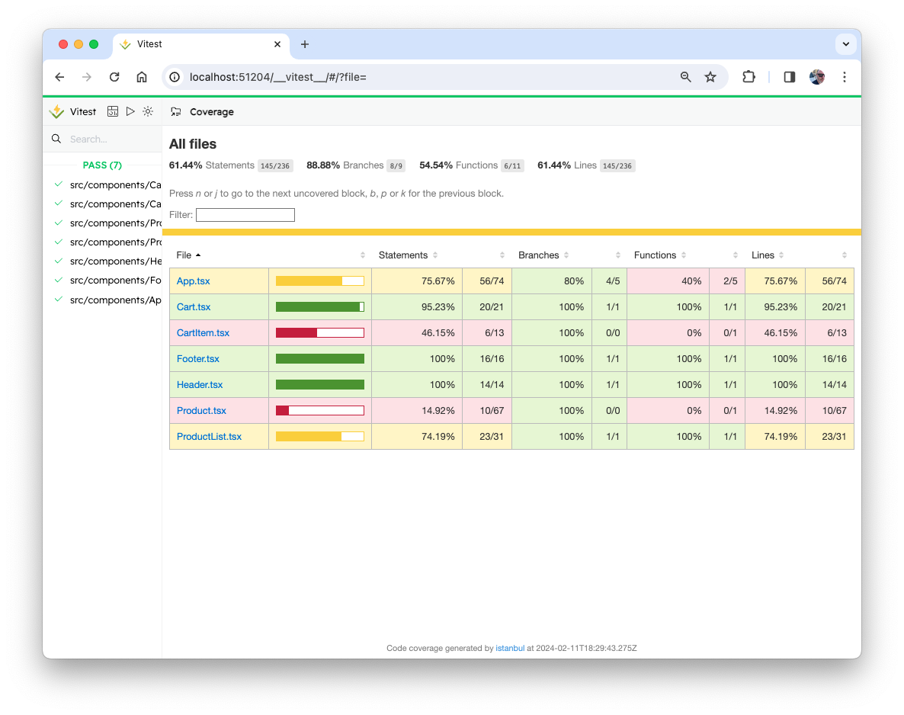

1. Write more tests, refine your existing tests, and increase your test coverage %. See the solution for more ideas of tests to write and how to write them.

# Lab 16: Implementing Redux

As your application grows, you may find it useful to transition to Redux. It's unlikely that our existing app would benefit at this point from Redux, but the process that we'll go through to convert it to Redux will show you the steps involved in a simplified example.

1. Install Redux, the react-redux library, and Redux toolkit.

npm install --save redux react-redux @reduxjs/toolkit

## Step 1: Create a store

1. In main.tsx, import configureStore from Redux toolkit.

import { configureStore } from '@reduxjs/toolkit';

1. In main.tsx, configure the store:

const store = configureStore({ reducer: rootReducer });

1. Import combineReducers from redux.

import {combineReducers} from 'redux';

1. Import Provider from react-redux.

import {Provider} from 'react-redux';

1. Import the reducers (which we'll create in a moment).

import {cart, products} from './reducers';

1. Create the root reducer.

const rootReducer = combineReducers({

cart: cart,

products: products

});

1. Wrap the App component in a Provider and pass the store to Provider as a prop.

createRoot(rootElement).render(

<Provider store={store}>

<App />

</Provider>

);

## Step 2: Write the reducers

1. Create a directory in **src** named **reducers**.
2. Create **index.js** inside **reducers**.

The next step is to define the ways in which the state of the cart can change. Changes in redux happen in response to actions. So, our reducer needs to listen for certain actions that correspond to different changes in the state of the cart and then make those changes.

1. Write and export the cart reducer function as a module. The cart reducer contains a switch statement with a case for each possible action that can happen in the cart.

export function cart(state = { items: [] }, action = {}){ switch(action.type) {

case 'CART_ADD':

return; //todo: finish this

case 'CART_REMOVE':

return; //todo: finish this

default:

return state; //no relevant action type

}

}

1. Inside the CART_ADD case, use the functionality from the addToCart function (in **App.tsx**) to add the productId passed by the action to the items array.

case 'CART_ADD':

return {

...state,

items: [...state.items, action.payload],

};

1. Inside the CART_REMOVE case, use the functionality from the removeFromCart function (in **App.tsx**) to remove the productId passed to it from the items array.

case 'CART_REMOVE':

return {

...state,

items: state.items.filter(

(item) => item.id !== action.payload.productId

),

};

1. Write and export the products reducer function (also in **reducers/index.js**). It should have one case, named LOAD_PRODUCTS which will update the state with the list of products.

export function products(state = { products: [] }, action = {}) {  
 switch (action.type) {  
 case 'LOAD_PRODUCTS':  
 return {  
 ...state,  
 products: action.products  
 };  
 default:  
 return state; //no relevant action type   
 }  
}

## Step 3: Write the Actions and Action Creators

1. Create a new directory in **src**, named **actions**.
2. Create a file named **index.js** inside **actions**, then write (and export) the functions inside it that will create the actions that trigger changes to the state inside the reducers we just wrote.

export function addToCart(product) {  
 return {  
 type: 'CART_ADD',  
 payload: {  
 ...product  
 }  
 }  
}  
  
export function removeFromCart(productId) {  
 return {  
 type: 'CART_REMOVE',  
 payload: {  
 productId  
 }  
 }  
}

export function loadProducts(products) {  
 return {type: 'LOAD_PRODUCTS', products}  
}

Now that we have the action creators that will be dispatched when the user interacts with the application, and we have the reducers that will mutate the state in response to those actions, the last step is to hook up the user interactions (button clicks) to the dispatch of the actions.

1. Import the action creator functions, the connect method of react-redux, and the bindActionCreator method into **pages/App.tsx**.

import * as actionCreators from '../actions';

import {bindActionCreators} from 'redux';

import {connect} from 'react-redux';

1. In **App.tsx** (below the function, but above the export statement) map the state to props and bind the action creators to the dispatcher.

const mapStateToProps = (state: any, props: any) => {

return {

itemsInCart: state.cart.items,

products: state.products.products,

};

};

const mapDispatchToProps = (dispatch: any, props: any) => {

return bindActionCreators(actionCreators, dispatch);

};

1. Use the connect method to merge mapStateToProps and mapDispatchToProps into App in the export statement at the bottom of **App.tsx**.

export default connect(mapStateToProps, mapDispatchToProps)(App);

## Step 4: Modify App.tsx to use the Redux store.

1. In **App.tsx**, remove the following:
   * The useState function calls for itemsInCart and for products.
   * The addToCart method
   * The removeFromCart method
2. Make sure the props object is a parameter of App

function App(props) {

1. Update the useEffect method to call the loadProducts method and pass it the products array from the custom hook. Make sure to put products into the dependency array so the effect with run when the custom hook returns the data.

useEffect(() => {

props.loadProducts(products);

}, [products]);

1. Modify the props passed to the ProductList and Cart components to use the props that are passed in from the connection to the Redux store.

<div className="col-md-8">

<ProductList

addToCart={props.addToCart}

removeFromCart={props.removeFromCart}

itemsInCart={props.itemsInCart}

products={props.products}

/>

</div>

<div className="col-md-4">

<Cart itemsInCart={props.itemsInCart} />

</div>

1. Fix any typescript errors that you have.
2. Try converting reducers/index.js and actions/index.js to TypeScript.

Test it out! Everything should now work with no additional changes.

1. Add a 'Remove' button to the CartItem component that causes the item to be removed from the cart.

## Step 5: Looking at Redux Toolkit

1. Redux Toolkit has a standard Vite template that demonstrates some best practices and patterns for using Redux. Run the following command outside of your react-bookstore folder to create a project with the Redux Toolkit template.

npx degit reduxjs/redux-templates/packages/vite-template-redux my-app

1. CD into the new project and run npm install.
2. Run npm run dev to see it running, then look through the code at how it works. Can you apply some of the other Redux Toolkit methods and conventions to the React Bookstore?

# Lab 17: Redux Thunk

Redux Thunk middleware allows you to write action creators that return functions rather than actions. This function can be used to delay the dispatch of an action, to cause the action to only be dispatched if a condition is met, or to fetch data asynchronously, for example.

In this lab, you'll use Redux Thunk to post a message to a server and receive a response when a **Checkout** button is clicked in the Cart component.

We're going to write an action creator containing a function that will perform an HTTP post. We'll be using the built-in fetch() method to do the API request, and we'll use Redux Thunk with Redux Toolkit's createAsyncThunk function to make the request prior to running a reducer.

1. We're going to write an action creator containing a function that will perform an HTTP post using the **axios** library. So, we'll need to install **axios** first.

npm install --save axios

1. In **actions/index.ts**, import axios at the beginning of the file.

import axios from 'axios';

1. Import createAsyncThunk into actions/index.js:

import { createAsyncThunk } from '@reduxjs/toolkit';

1. In **actions/index.js**, add a new action creator for submitting the cart.

export const submitCart = createAsyncThunk('CHECKOUT', async (data) => {

const res = await axios.post('http://localhost:8080/checkout', data);

return res.data;

});

1. Pass the submitCart action creator from App to the Cart**.**

<Cart removeFromCart={props.removeFromCart} submitCart = {props.submitCart} itemsInCart={props.itemsInCart}/>

1. Add a button to the Cart that calls the submitCart method when clicked and passes props.cartItems into it. Wrap it in a div element so that it will appear below the cart items and the total.

<div><button onClick={()=>props.submitCart(props.itemsInCart)}>

Check Out

</button></div>

1. Run your app, add some items to the cart, and then open the Redux DevTools and click the Check Out button. You should see that the CHECKOUT/rejected action is dispatched.
2. Open a new terminal window and change to the **starter/lab17/server** directory.
3. Run npm install in the server directory
4. Run the server by entering npm start.
5. Click the **Check Out** button in the React app.

You should see that the CHECKOUT/fulfilled action was dispatched. In the browser console, you should see the return data from the server.

Right now, the React Bookstore doesn't do anything in response to the action, because we don't have a reducer that's listening for it. Let's fix that.

1. In **reducers/index.js**, write a new case in the cart reducer for the CHECKOUT action.

case 'CHECKOUT/fulfilled':

return {

};

1. Inside the CHECKOUT case, we'll return the state, with the items array emptied, which will just empty the cart.

case 'CHECKOUT/fulfilled':  
 return {  
 **...state,  
 items: []**  
 };

1. Make sure that the server is running, then run npm start to build your React app and test it out by adding and removing items from the cart and then checking out.

# Lab 18: Persisting data in localStorage using Redux

Our application is now using React and Redux together. We've implemented an Ajax call to

fetch the initial data for our store. But we have an opportunity for improvement. Note that

every time you refresh the page, it forgets what was in the cart. What if our user wants to close

the browser and then come back at a different time?

­

In this lab, we'll fix that by writing our cart to localStorage every time it changes. And we'll read the stored cart whenever the client starts up our application.

1. Add a new action creator to actions/index.js for reading the cart from localStorage:

export function readCartFromLocalStorage() {

let cart = localStorage.getItem('itemsInCart');

cart = JSON.parse(cart);

console.log(cart);

return {

type: 'READ_CART',

payload: cart || [],

};

}

1. Create a new reducer case for "READ_CART".

case 'READ_CART':

return {

...state,

items: action.payload || [],

};

1. Import readCartFromLocalStorage into useBooks.
2. Import useDispatch from react-redux into useBooks.
3. Call useDispatch inside useBooks() to return the dispatch function.

const dispatch = useDispatch();

1. After the products are loaded, call dispatch(readCartFromLocalStorage);
2. Run and test. You should have no errors, but you should still see an empty cart.

Why? Because there is nothing in localStorage yet.

Let's write to localStorage now. We'll do it after every change to the cart.

We should write something to local storage after every change to the cart.

1. After the line in main.tsx that creates the store, subscribe localStorage to the store, so that whenever the store changes the cart will be written to localstorage:

store.subscribe(() => {

localStorage.setItem(

'itemsInCart',

JSON.stringify(store.getState().cart.items)

);

});

1. Run and test. Can you now add books and remove books and have them persist each time you re-visit the bookstore? If so, you've got it right!

# Lab 19: React Router

In this lab, you'll use React Router to create a separate route for the shopping cart.

1. Install react-router-dom
2. Import BrowserRouter as Router into **main.tsx** and wrap the Router component around the <Provider> element in createRooter.render()
3. In **App.tsx**, import Routes and Route from react-router-dom.
4. In App's return statement, change the page layout to a 1-column layout by removing the </div> and <div> from between Cart and ProductList and changing the className passed to the outside div to col-md-12.
5. Replace ProductList and Cart with a Routes component containing two Routes. The first should render ProductList when the path is exactly '/' and the second should render Cart when the path is '/cart'.

<Routes>

<Route

path="/"

element={

<ProductList

products={products}

itemsInCart={props.itemsInCart}

addToCart={props.addToCart}

removeFromCart={props.removeFromCart}

/>

}

/>

<Route

path="/cart"

element={

<Cart

itemsInCart={props.itemsInCart}

removeFromCart={props.removeFromCart}

submitCart={props.submitCart}

/>

}

/>

</Routes>

1. Test it out. When you first start up the app (and the route is '/') it should display the ProductList, and if you change the url in the address bar to '/cart' it should display the cart. Everything should still work.
2. Import Link from react-router-dom into Header and create a nav bar that links to the home page and to the cart.
3. Challenge: Make a Shopping Cart button component that displays the number of items in the cart in the header and that links to the shopping cart (using react-router-dom's Link component). You can use the fontawesome React component to render the icon: **https://fontawesome.com/v5.15/how-to-use/on-the-web/using-with/react**

# Lab 20: Microfrontends with Single SPA

In this lab, you'll use the Single SPA framework to create a microfrontend.

1. In an empty directory that's not inside of any other Node project (no **package.json** at a higher level), open a new terminal window and invoke create-single-spa.

npx create-single-spa --moduleType root-config

1. Answer all the questions that create-single-spa asks, choosing the defaults whenever possible.
2. Run **npm start** in your new project and open a browser to [**http://localhost:9000**](http://localhost:9000/).

You now have a root config and an example application. You'll see some instructions for what to do next in the sample application that's running at port 9000. Read through those instructions. We're going to use Single SPA to run two React applications and share dependencies between them.

1. Open a new terminal window and generate a single-spa application by running:

npx create-single-spa --moduleType app-parcel

1. When you're asked for a directory and a name for the application, name the directory something creative like 'app1' and the app ‘my-first-app.’
2. Once it finishes, cd to your new directory and run **npm start**.
3. Open a browser and go to the localhost post that it gives you when it starts up. (probably localhost:8001).
4. Read through this page, but don't follow these instructions just yet.
5. Open **src/index.ejs** in your root config (not in your app1 subdirectory) and find the script element with type="systemjs-importmap". Since all of our microfrontends will use React, we need to add React and ReactDOM to this import map.
6. Go to [**https://cdnjs.com/libraries/react**](https://cdnjs.com/libraries/react) and get the latest link for the React library (it should have **umd** in the URL) and add it to the **importmap**, then do the same for the ReactDOM library (you can just copy the same url and change "react" to "react-dom" in the URL.
7. When you're finished, your importmap should look like this:

<script type="systemjs-importmap">

{

"imports": {

"single-spa": "https://cdn.jsdelivr.net/npm/single-spa@5.9.0/lib/system/single-spa.min.js",

"react": "https://cdnjs.cloudflare.com/ajax/libs/react/18.2.0/umd/react.production.min.js",

"react-dom": "https://cdnjs.cloudflare.com/ajax/libs/react-dom/18.2.0/umd/react-dom.production.min.js"

}

}

</script>

1. Open **src/microfrontend-layout.html** and find the <route> element. Add your new application as a 2nd application. You can get the value for the name property from the **package.json** file in your **app1** directory. For example:

<application name="app1/@minnick/my-first-app"></application>

1. In your root config's **src** directory, open **index.ejs** and add your application to the importmap. Note that there are two importmaps in the file, and you should add your application to both. Here's an example of what you should add:

"@minnick/my-first-project": "//localhost:8081/minnick-my-first-app.js",

1. Stop both your root config and you application and restart them. In your browser, you should now see a message saying that your application is mounted. It will look like this:

@minnick/my-first-app is mounted!

1. Remove the sample application from your **src/index.ejs** so your new application is the only one being rendered.
2. Create a second application and render that one in addition to the first.

# Bonus Lab: Authentication with JWT

In this lab, you'll learn how to implement authentication in the container component and then pass an authentication token to micro frontends.

1. Read the following article to learn about implementing JWT in React

https://www.alibabacloud.com/blog/how-to-implement-authentication-in-reactjs-using-jwt_595820

1. Use this technique, or another of your choosing, to implement authentication and create a protected "Account Info" area in the bookstore app.

# Bonus Lab: React Asteroids

Convert the JavaScript application you built in Lab 4 to a React application.